

**PLATTERLY**

**MINOR PROJECT - I**

**Submitted in Partial Fulfilment of the Requirements for the Award of the Degree of**

**MASTER OF COMPUTER APPLICATIONS**

**(M.C.A.)**

**BY**

**SACHIT GAMBHIR (02911604422),**

**MANAN ARORA (36211604422),**

**PRACHI GUPTA (08011604422)**

**MCA – 1st SEMESTER**



**BHARATI VIDYAPEETH’S INSTITUTE OF COMPUTER APPLICATIONS AND MANAGEMENT (BVICAM)**

**(GURU GOBIND SINGH INDRAPRASTHA UNIVERSITY)**

**NEW DELHI**

**February, 2023**

**CANDIDATE’S DECLARATION**

We hereby declare that the work which is being presented in this project work entitled “**Platterly**” in partial fulfillment of the requirements for the award of the degree of **Master in Computer Applications at Bharati Vidyapeeth’s Institute of Computer Applications and Management (BVICAM), New Delhi** is an authentic record of our own work carried out during the period November 2022 to January 2023 under the supervision and guidance of

**Mr. Uttam Singh (Assistant Professor, BVICAM), Dr. Parul Arora, Dr. Ritika Wason, Dr. Vaishali Joshi.**

We have not submitted the matter embodied in this project work anywhere for the award of any degree or diploma.

SACHIT GAMBHIR (02911604422)

MANAN ARORA (36211604422)

PRACHI GUPTA (08011604422)

**ACKNOWLEDGEMENT**

It is our proud privilege to express our profound gratitude to the entire management of Bharatia Vidyapeeth’s Institute of Computer Applications and Management and teachers of the institute for providing us with the opportunity to avail the excellent facilities and infrastructure. The knowledge and values inculcated have proved to be of immense help at the very start of our career. Special thanks to Hon’ble Founder, Bharati Vidyapeeth, Pune for having provided us an excellent infrastructure at BVICAM.

We are grateful to **Dr. Parul Arora, Dr. Ritika Wason, Dr. Vaishali Joshi** (Project Guide, BVICAM, New Delhi) for their astute guidance, constant encouragement and sincere support for this project work.

We feel pride and privileged in expressing our deep sense of gratitude to all those who have helped us in presenting this assignment. We would be failing in our endeavour if I do not place my acknowledgement**.**

**Sachit Gambhir, Manan Arora, Prachi Gupta**

Enroll. No. 02911604422, 36211604422, 08011604422

**ABSTRACT**

In this minor project, we have developed a web-based application for managing Tiffin Service. The Web-application is developed using PHP, HTML, CSS, MySQL technology. MySQL database management system (DBMS) is used to manage the database for the application. There are mainly 4 modules of the system: registration, order processing, customers’ record management.

**TABLE OF CONTENTS**

|  |  |  |
| --- | --- | --- |
|  | | **Page No.** |
| **CHAPTER 1: INTRODUCTION** | | |
| 1.1 | Problem Description | 5 |
| 1.2 | Proposed Solution | 6 |
| 1.3 | Team Structure and Role | 7 |
| 1.4 | Deliverables | 8 |
| **CHAPTER 2: PROJECT DESCRIPTION** | | |
| 2.1 | System Specification | 9 |
| 2.2 | Methodology used | 10 |
| 2.3 | Modules and their description | 11 |
| **CHAPTER 3: FUNCTIONALITIES** | | |
| 3.1 | ER Diagrams | 13 |
| 3.2 | Usecase Diagram | 19 |
| 3.3 | Screenshots | 22 |
| **CHAPTER 4: CONCLUSION AND FUTURE SCOPE** | | |
| 4.1 | Conclusion And Future Scope | 34 |
| 4.2 | Bibliography | 35 |

**CHAPTER1: INTRODUCTION**

**Introduction**: **Platterly** is a web-based application that provides customers with a platform to order tiffin services online. This project was developed using HTML, CSS, MySQL, and PHP to create a web application that is easy to use and efficient. The web application includes features such as user registration, menu display, shopping cart, online payment gateway, and order history display.

Methodology: The project was developed using the Waterfall methodology, which involves sequential development and testing. The project was divided into various phases, including requirements gathering, design, implementation, testing, and maintenance. The project team consisted of developers, designers who worked together to develop and test the web application.

Features: The Online Tiffin Service web application includes the following features:

1.User registration and login system

2.Menu display

**User registration and login system:** The user registration and login system allows users to create an account and login to the web application. Users can update their profile information and manage their orders. The system stores user information, including name, email address, phone number, and password, in a MySQL database.

**Menu display:** The menu display feature allows users to view the available tiffin services and select the ones they want to order. The menu is categorized by type of meal, such as breakfast, lunch, and dinner. The menu items are stored in the MySQL database and displayed on the web page using HTML and CSS.

Shopping cart: The shopping cart feature allows users to add and remove tiffin services from their cart before placing an order. The cart is stored in a MySQL database and displayed on the web page using HTML and CSS. The user can view their cart at any time and adjust the quantity of items in the cart.

**Order history display:** The order history display feature allows users to view their past orders and track the status of their current orders. The order history is stored in a MySQL database and displayed on the web page using HTML and CSS. Users can view the order details, including the date, time, and total cost of the order.

* 1. **Problem Description**

The problem that the tiffin service website aims to address is the inconvenience and hassle of preparing meals for busy individuals who do not have the time or skills to cook nutritious meals. The website provides an online platform for users to order and receive home-cooked meals conveniently and at an affordable cost. The website's primary goal is to make healthy and tasty food available to everyone, regardless of their lifestyle or dietary preferences. Additionally, the website provides an opportunity for talented home cooks to share their culinary skills with the community, earn a decent income and promote healthy eating habits. The website also helps to reduce food wastage by producing only the required quantity of meals as ordered by customers. The website is a one-stop solution for users looking for healthy and delicious meal options while saving time and effort in their busy lives.

**1.2 Proposed Solution**

Platterly tiffin service website is a proposed solution to the above-mentioned problem. The website is designed to be user-friendly and easy to navigate, making it easy for customers to order and receive home-cooked meals. The website's main features include:

1. **Meal selection:** The website provides a wide range of meal options, including vegetarian and non-vegetarian options. Customers can choose from a variety of meals, including breakfast, lunch, and dinner, and order according to their dietary requirements.
2. **Easy ordering:** The website has an easy-to-use ordering system that allows customers to select their meals, choose the delivery date and time, and make payments online. Customers can also schedule recurring orders to ensure they never miss a meal.
3. **Customization:** The website allows customers to customize their meals according to their preferences, such as spice level, serving size, and dietary restrictions.
4. **Home-cooked meals:** The meals are prepared by talented home cooks who are passionate about cooking healthy and delicious food. The meals are prepared in a hygienic environment using fresh ingredients.
5. **Delivery:** The website provides a reliable and timely delivery service to ensure that the meals reach the customers on time and in good condition.
6. **Subscription:** The website provides a subscription service, which allows customers to receive regular meals on a Fortnightly or monthly basis.

**Platterly** tiffin service website aims to provide customers with a convenient, affordable, and healthy meal option while also providing an opportunity for talented home cooks to share their culinary skills with the community.

* 1. **Team Members And Roles**

**Team Members**

1. **Manan Arora (36211604422)**
2. **Prachi Gupta (08011604422)**
3. **Sachit Gambhir (0291160442)**

**Role of Each Member: -**

1. **Customer Module: By Manan Arora (Web Development Front-End)**

* Provides Login Interface for registered customers.
* Provides a Sign-up Interface for new customers.
* Providing wide range of tiffin as per their taste.
* Providing customers to update their account details.
* Provide user-friendly interface to avail tiffin service as per their requirement.
* Report Writing

**2.Tiffin Vendor Module: By Prachi Gupta (Web Development Front-End And Back-End)**

* Providing Login Interface for registered tiffin vendors
* Provides a Sign-up Interface for new tiffin vendors.
* Providing interface to list their menu items and pricing after negotiation and approval by admin.
* Updating their profile, including credentials.
* Report Writing

**3.Admin Module: By Sachit Gambhir (Web Development Front-End And Back-End)**

* Managing customers, tiffin vendors details.
* Managing tiffin orders.
* Updating details of users and vendors.
* Updating menu details for each vendor.
* Removing dormant users and vendors.
* Report Writing
* Project Presentation

**1.4 Deliverables**

The following are the deliverables for the Platterly Tiffin Service website project:

**Project Plan** - A detailed project plan outlining the scope, objectives, timelines, and resources required to complete the website.

**Website Design** - A website design that is visually appealing, user-friendly, and consistent with the Platterly Tiffin Service brand.

**Home Page** - A home page that provides an overview of Platterly Tiffin Service, including the menu, delivery areas, and ordering process.

**Menu Page** - A menu page that displays the different meal options available, including descriptions, prices, and nutritional information.

**About Us Page** - An about us page that provides information about the Platterly Tiffin Service team, their mission, and values.

**Ordering System** - An online ordering system that allows customers to place orders, make payments.

**Admin Panel** - An admin panel that allows the Platterly Tiffin Service team to manage the website, view orders, and update the menu.

Testing and Quality Assurance - Comprehensive testing of the website to ensure that it is fully functional, secure, and meets the requirements of the project plan.

**Deployment and Maintenance** - Deployment of the website to a web server and ongoing maintenance and support to ensure that the website remains up-to-date and operational.

**CHAPTER 2: Project Description**

**2.1 System Specification**

1. **Hardware Requirements**

|  |  |
| --- | --- |
| Processor | Intel i3 9400f |
| RAM | 4 GB |
| Hard Disk | Minimum 20 GB |

**(ii)Software Requirements**

|  |  |
| --- | --- |
| The Operating System | Windows 10 |
| Front-End Tool | Microsoft Edge / Chrome |
| Code Editor | Visual Studio Code, Notepad++ |
| Languages | PHP,HTML, CSS |
| Internet | High speed internet |

**2.2 Methodology Used**

The **Waterfall methodology** is a traditional software development methodology that follows a sequential approach to software development. It involves the following steps:

* **Requirements Gathering:** In this phase, the project team gathers all the requirements for the Platterly tiffin service website.
* **Design:** The next step is to create a design for the website based on the requirements gathered. This includes creating wire frames and visual designs for the website.
* **Development:** The website is developed based on the design created in the previous step. The development team builds the website's front-end, back-end, and database components.
* **Testing:** In this phase, the website is tested to ensure that it meets the requirements and functions as expected. This includes conducting functional, performance, and security testing.
* **Deployment:** Once the website is tested and approved, it can be deployed to a live server or hosting environment.
* **Maintenance:** After the website is launched, it requires ongoing maintenance and support to ensure that it continues to function correctly and meet the needs of the users.

**2.3 Modules And their Description**

1. **Customer Modules**

* **User Registration**: Customers should be able to register themselves by providing basic information like name, email address, phone number, and delivery address. After registration, the system should create a customer account and send a confirmation email to the customer.
* **User Login**: Registered customers should be able to log in to their accounts using their email address and password. Logging in will allow them to access their account information, view their order history, and track their current orders.
* **Order Placement**: Customers should be able to place an order by selecting their desired meal options from the menu, specifying their delivery address, and making a payment using a secure payment gateway. The system should also provide an estimated delivery time based on the delivery address.
* **Account Management:** Customers should be able to manage their account information, such as updating their delivery address, phone number, or password.

1. **Tiffin Vendor Modules**

* **Registration:** The tiffin vendors should be able to register themselves on the website by providing their details such as name, contact information, and location.
* **Profile Management:** Once registered, the tiffin vendor should be able to create and manage their profile on the website. The profile should contain information about their menu, pricing, and delivery options.
* **Menu Creation:** The tiffin vendor should be able to create and manage their menu on the website. They should be able to add, edit, and remove items from their menu as per their availability and pricing.
* **View orders:** The tiffin vendor should be able to view orders placed/confirmed by users after successful payment.

1. **Admin Modules**

* **Order management:** The admin module would allow the website owner to view and manage orders that have been placed. This would include the ability to update order status, add notes to an order, and cancel orders if necessary.
* **Customer management:** The admin module would allow the website owner to manage customer accounts, including adding new customers, editing customer information, and viewing order history.
* **Payment Order management:** The admin module would allow the website owner to manage the menus that are available for customers to order from. This would inclu

**CHAPTER 3: Functionalities**

**3.1 ER DIAGRAM**

Entity – Relationship model (ER model) in software engineering is an abstract way to describe a database. This article refers to the techniques proposed in Peter Chen's 1976 paper. However, variants of the idea existed previously, and have been devised subsequently such as super type and subtype data entities and commonality relationships.

**For Customers Table**

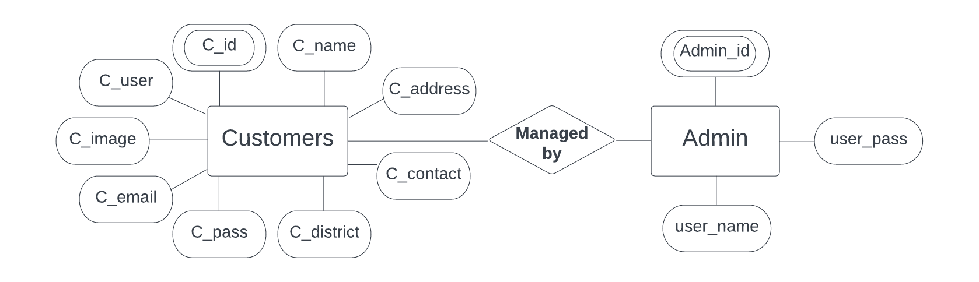

**For Vendor Table**

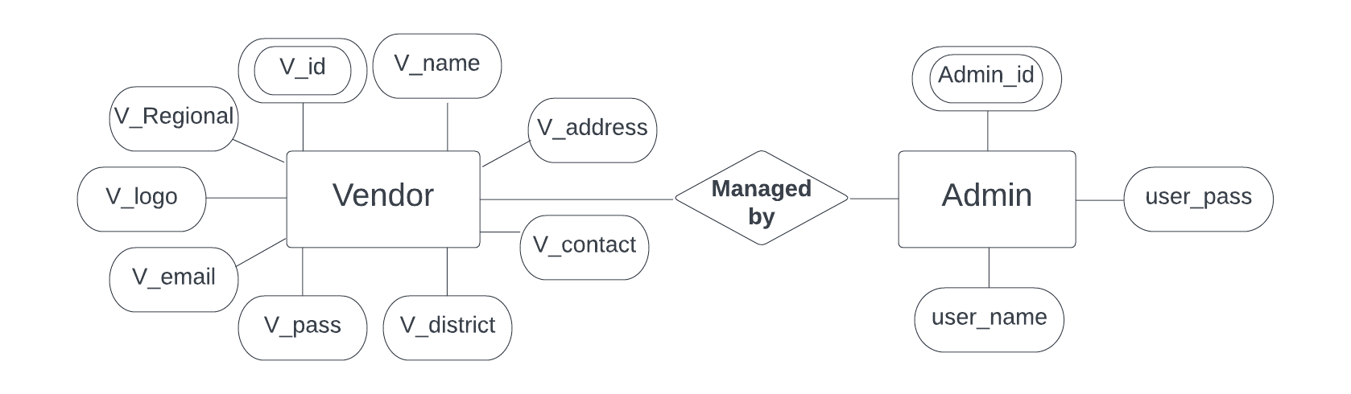

**For Meals Table**

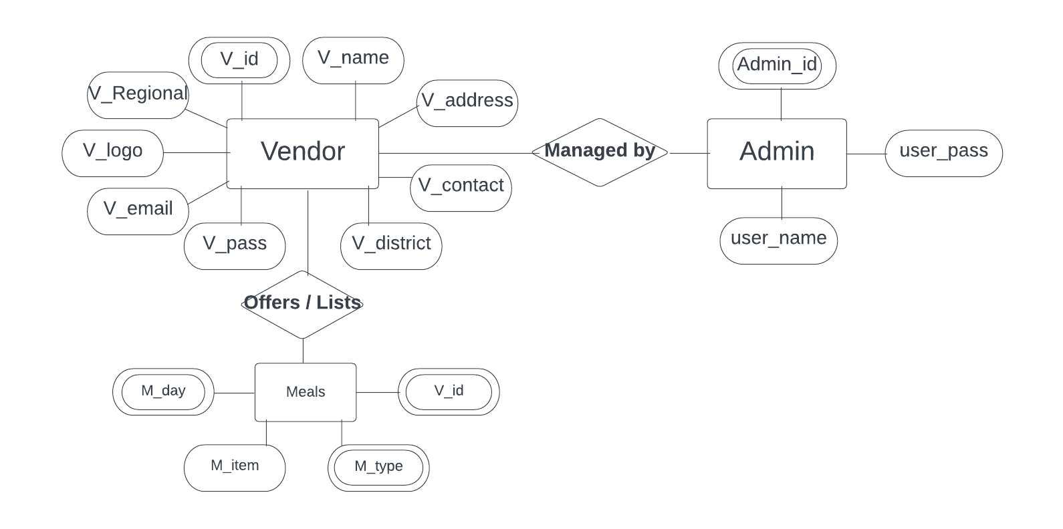

**For Regional Table**

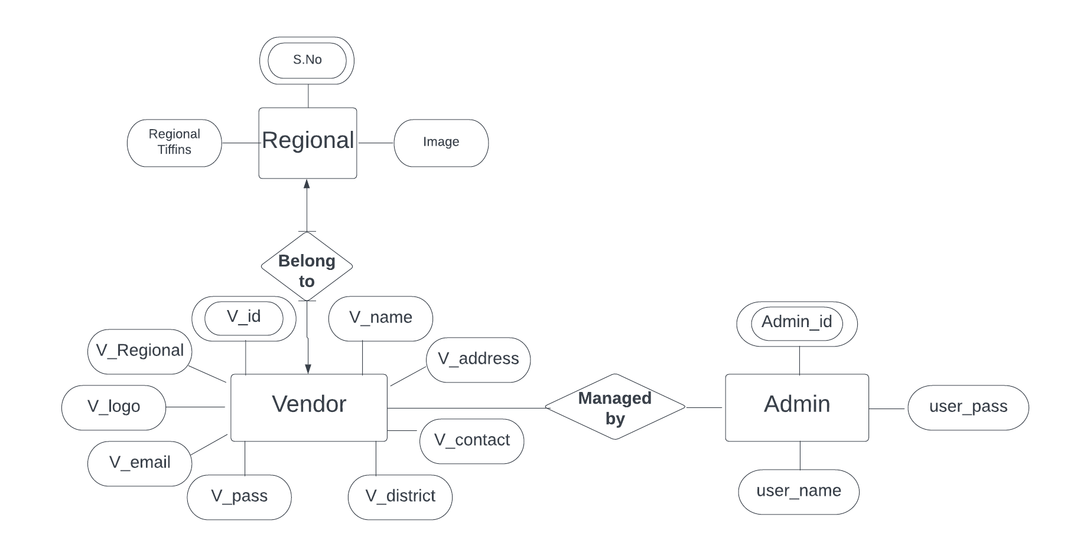

**For Rates Table**

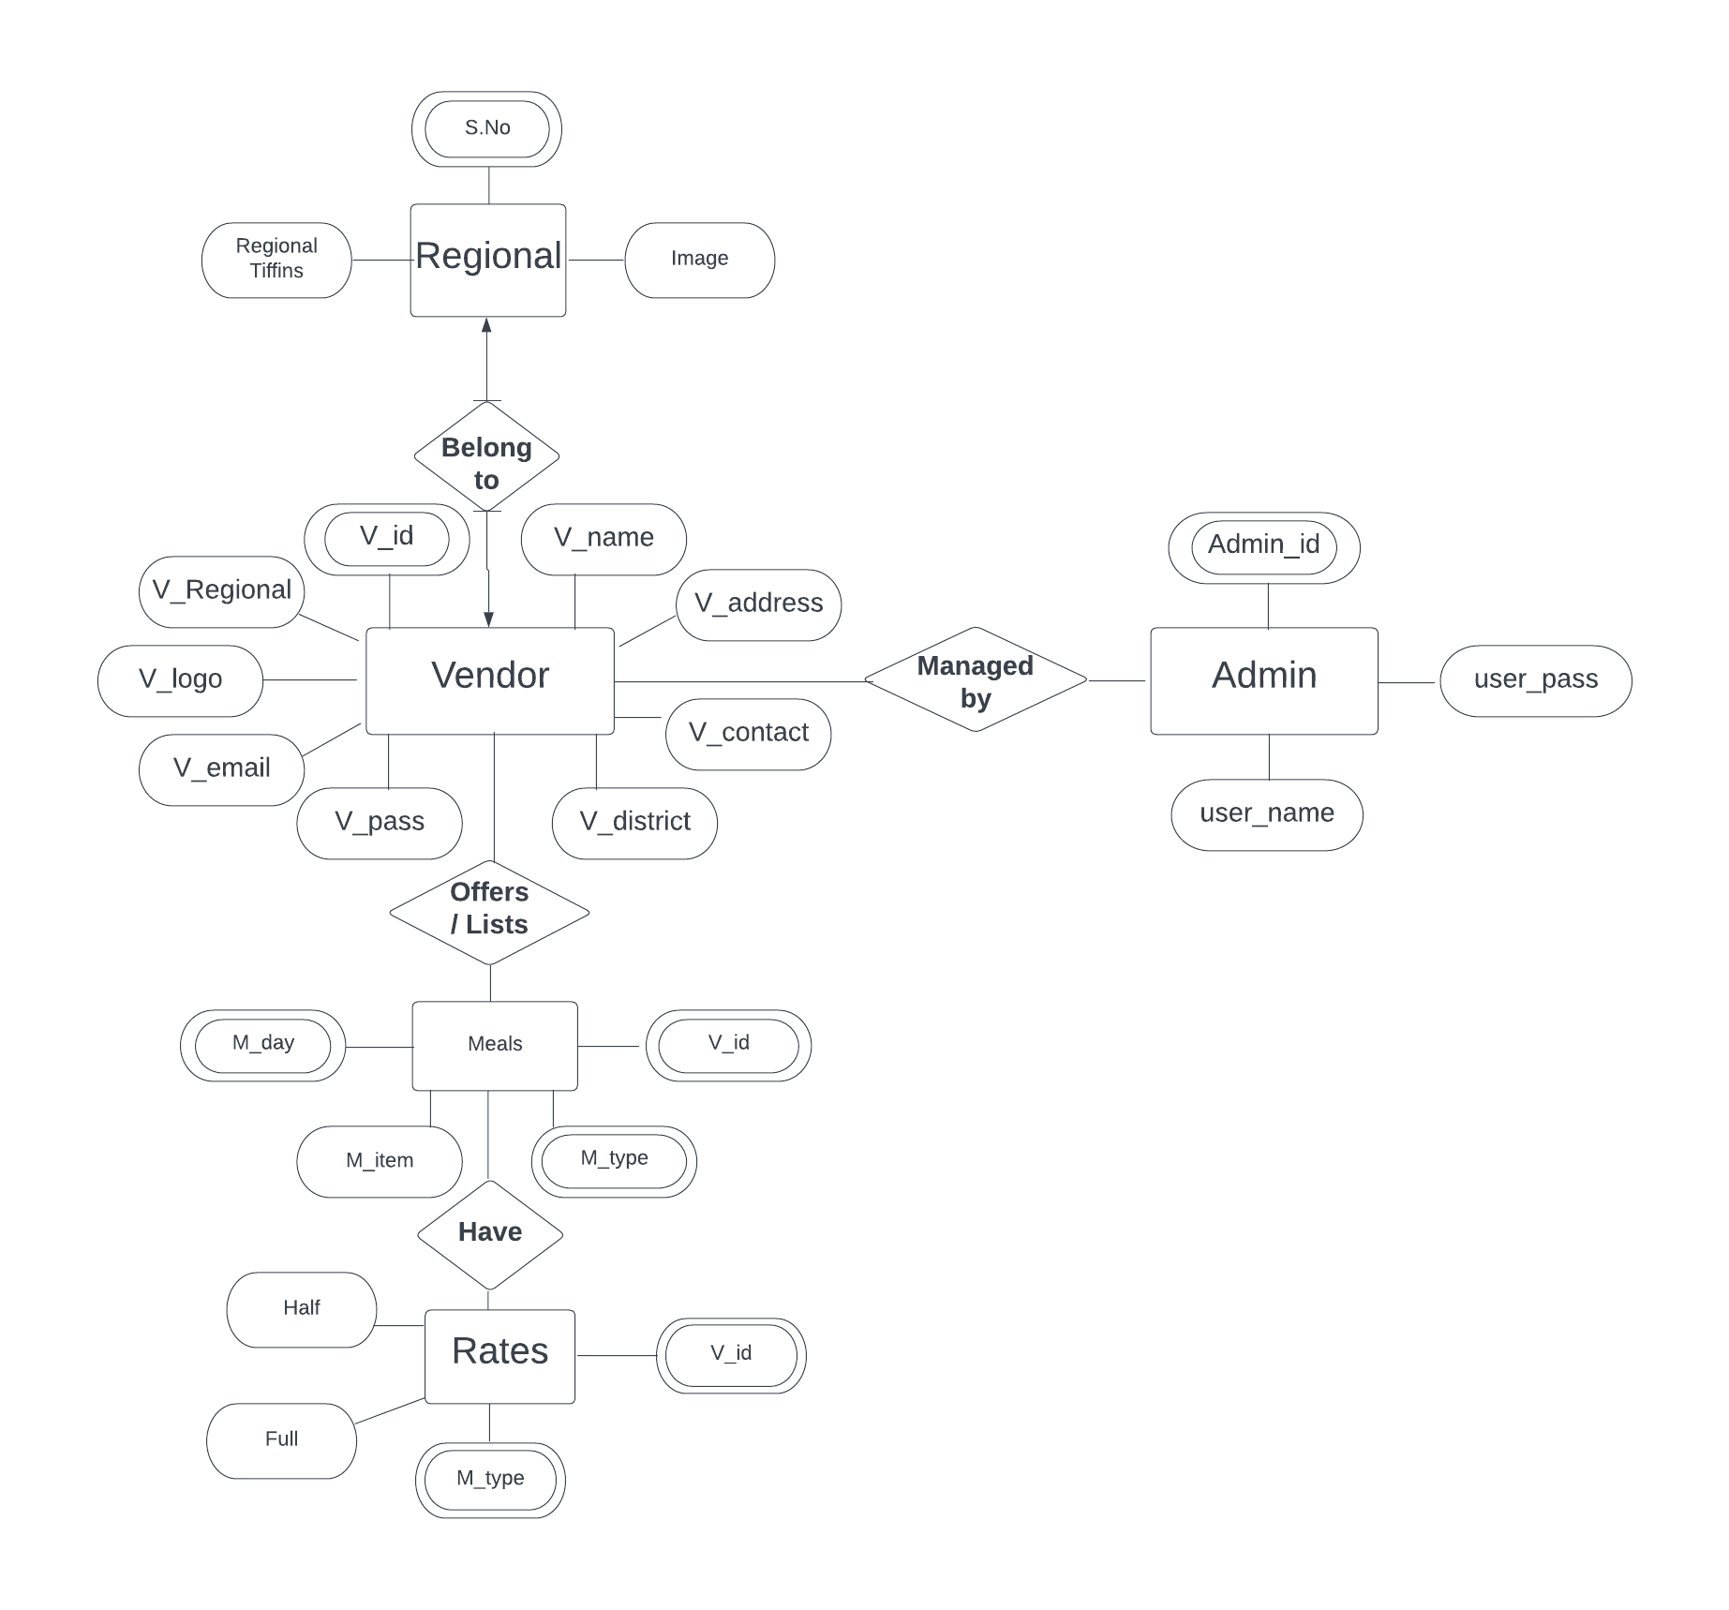

**For Bill_det & Payment_det Tables**

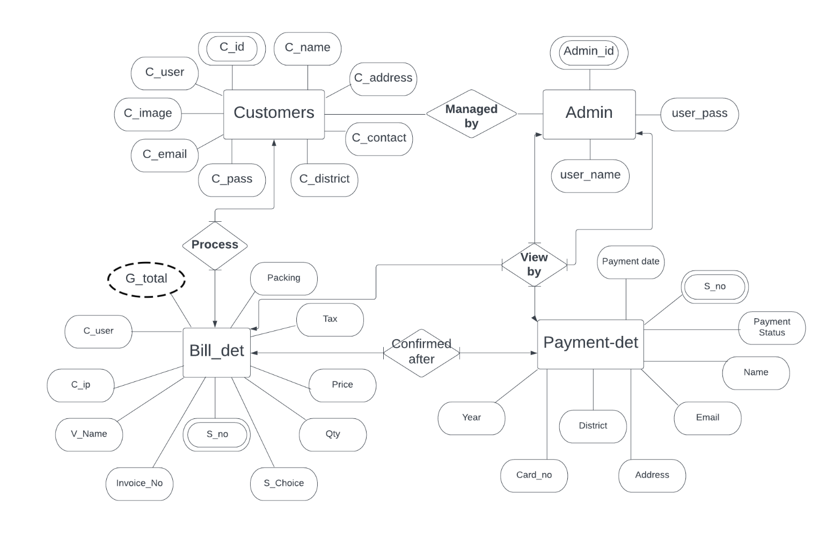

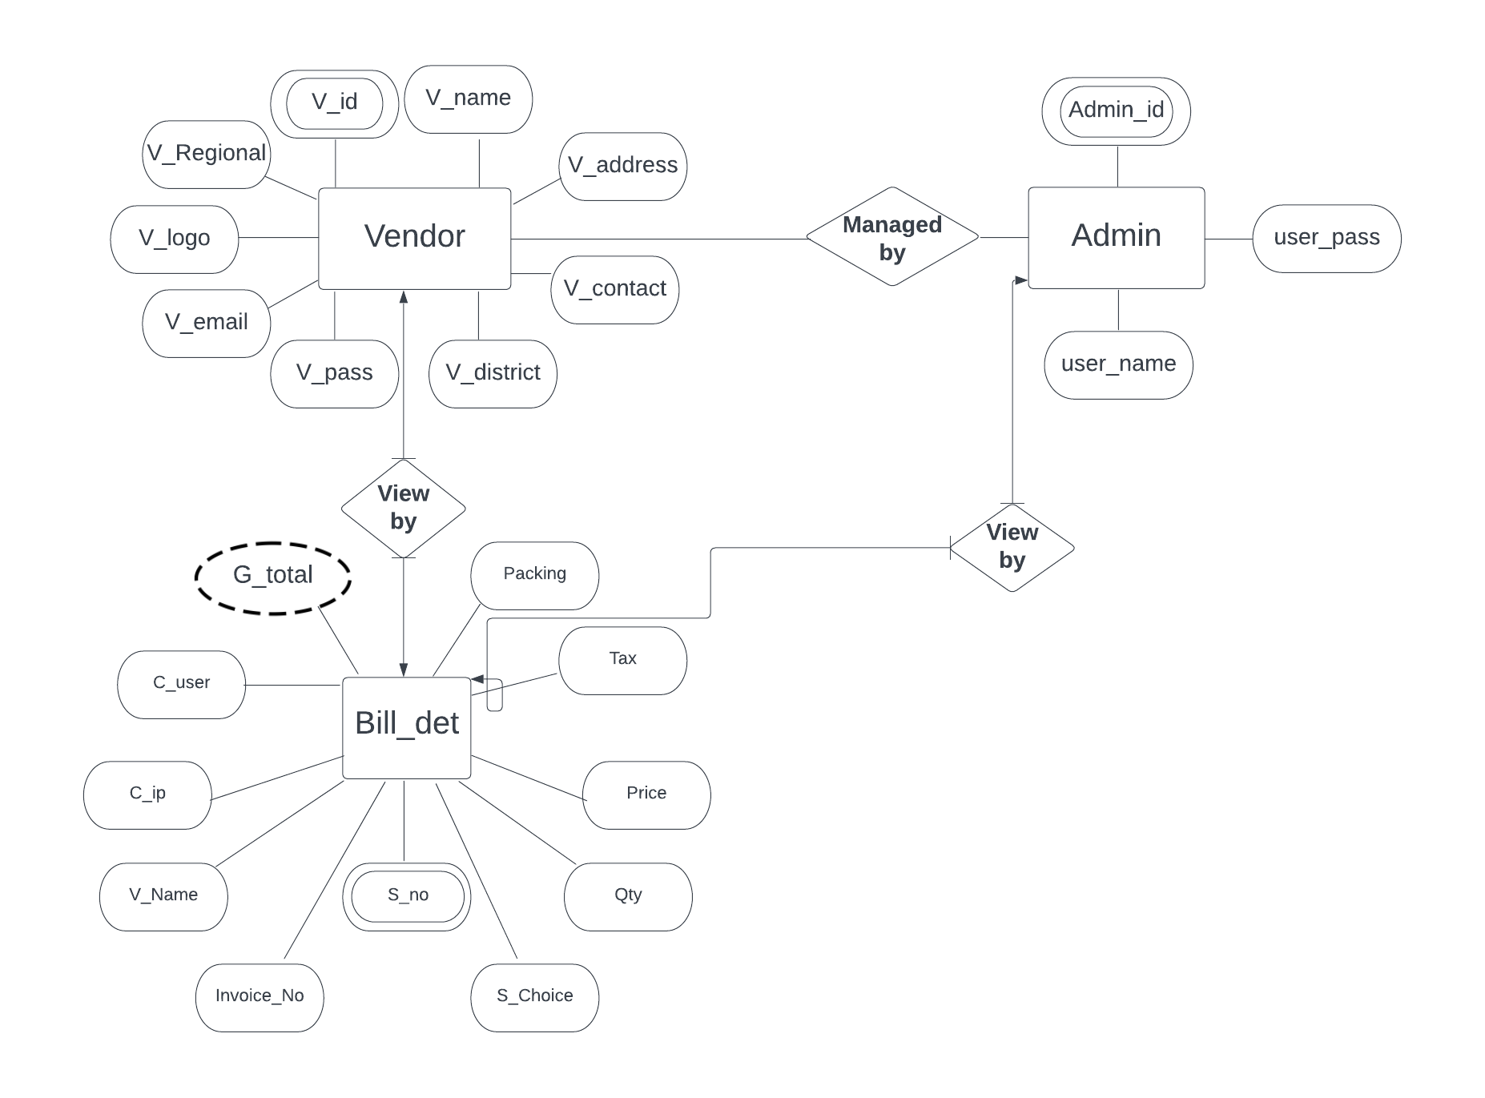

ER Diagram made using lupid:

[**File link**](https://lucid.app/lucidchart/400cc31a-d231-4ceb-ab64-7aac6c8052d6/edit?viewport_loc=-560%2C3644%2C2931%2C1337%2C0_0&invitationId=inv_94371ff6-d38a-430e-a91a-67484d706b04)

**3.2 THE USE CASE APPROACH**

A use case is a set of scenarios that describe an interaction between a user and a system.

A use case diagram displays the relationship among actors and use cases. The two main components of a use case diagram are use cases and actors.

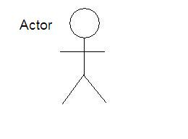**Fig. 3.1 Actor and Usecase**

**USE CASE**

**An actor is represents a user or another system that will interact with the system you are modelling.**

**A use case is an external view of the system that represents some action the user might perform in order to complete a task.**

CUSTOMERS

ADMIN

**Fig.3.2 Interaction between user and admin**

**Fig.3.2 Interaction between user and admin**

In The above diagram there are 2 actors or users who use the system. These two users are as follows:

1. User-The customer is allowed to login to the system, logout of it, order tiffin, make payments and edit details and credentials.
2. Admin-The admin can also login and logout of the system. Other than that the admin manage customers and view payments and orders.

VENDORS

ADMIN

**Fig.3.2 Interaction between user and admin**

**Fig.3.2 Interaction between vendor and admin**

In The above diagram there are 2 actors or users who use the system. These two users are as follows:

1. Vendors-Vendor is allowed to login to the system, logout of it, list menu items, view order and edit details and credentials.

2. Admin-The admin can also login and logout of the system. Other than that the admin manage customers and view payments and orders.

**3.3 IMPLEMENTAION**

**HOME PAGE:**

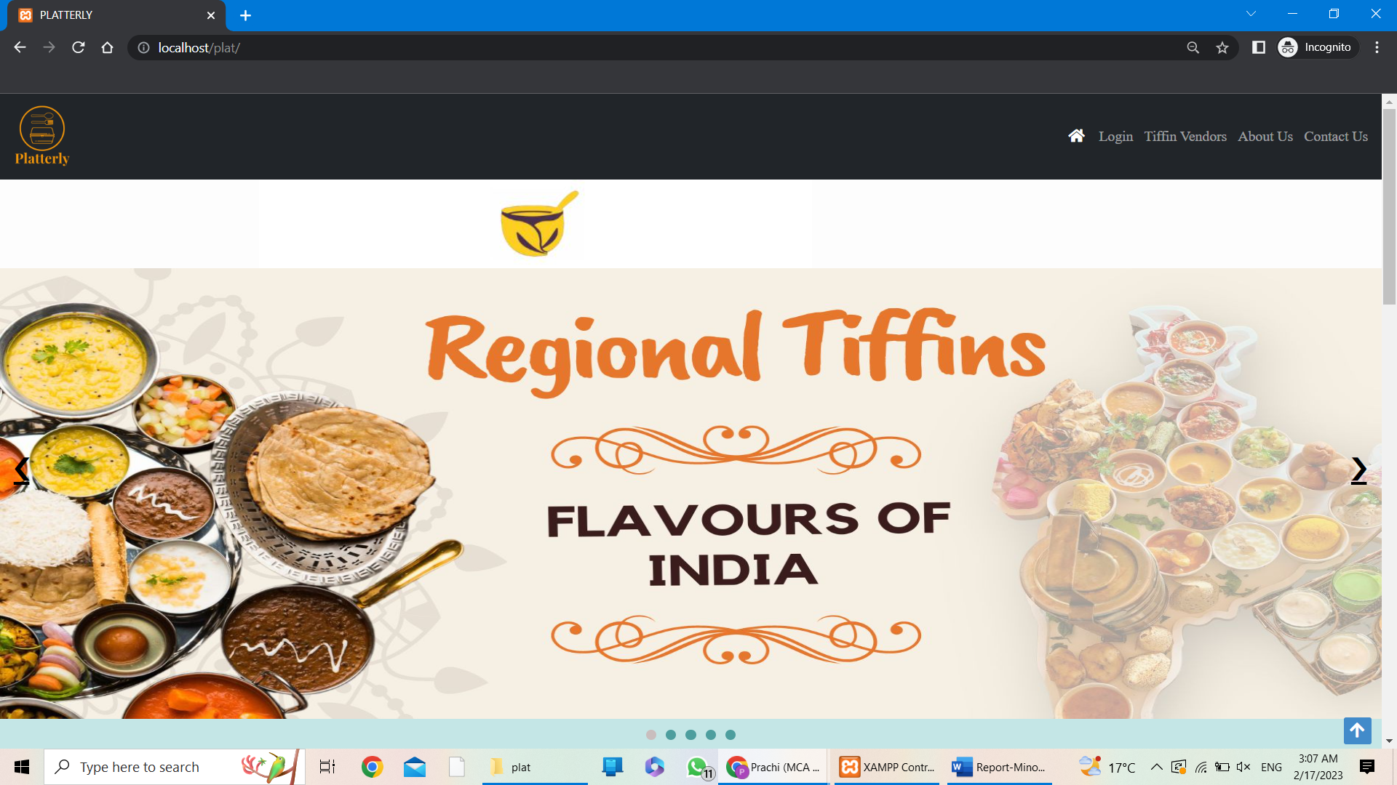

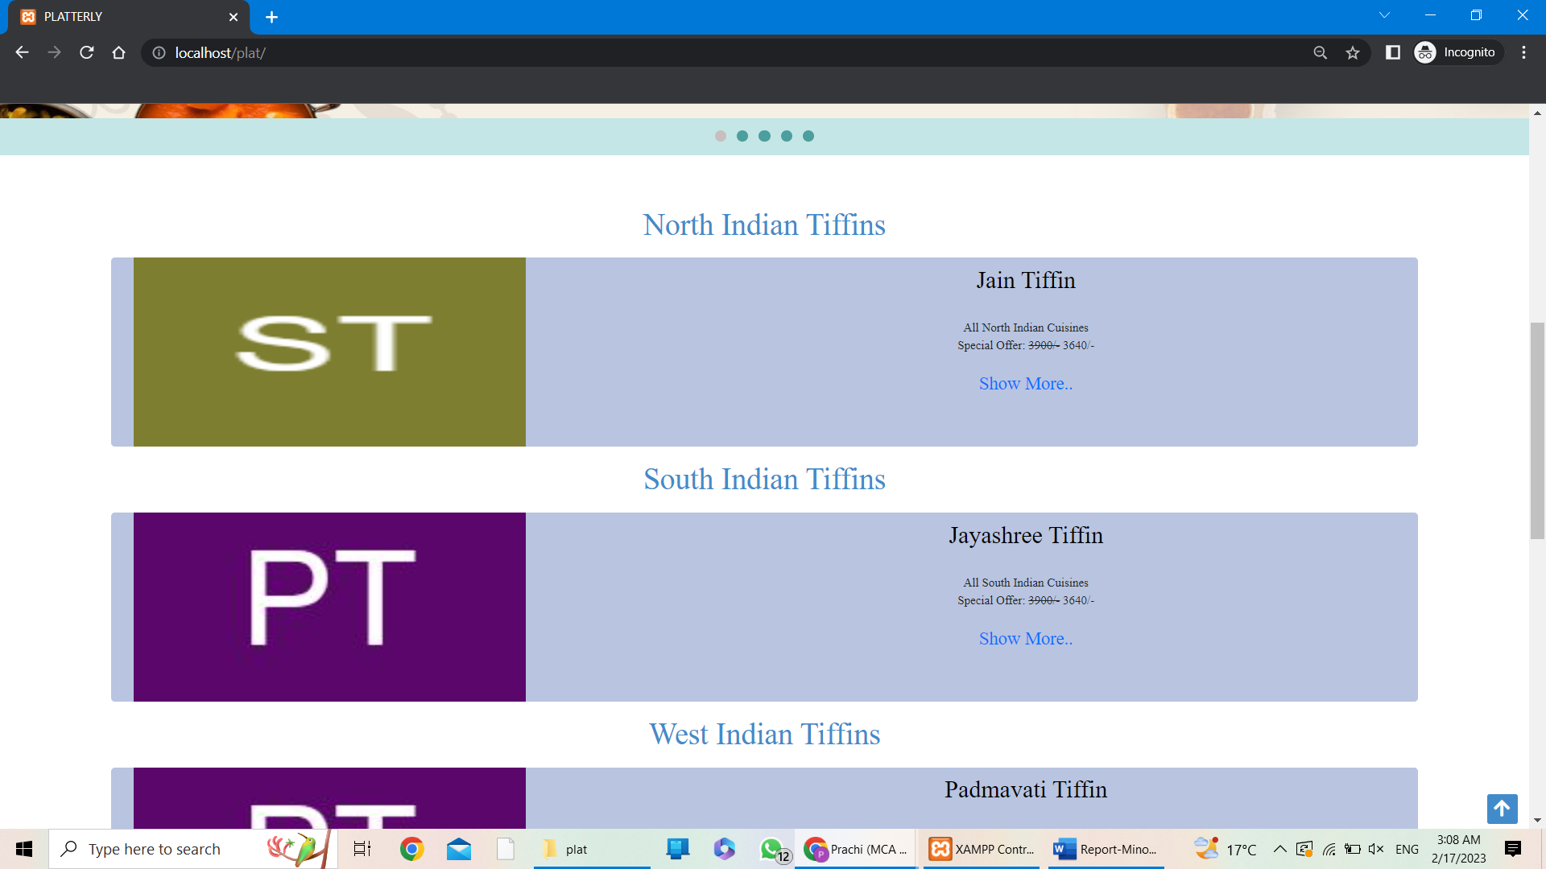

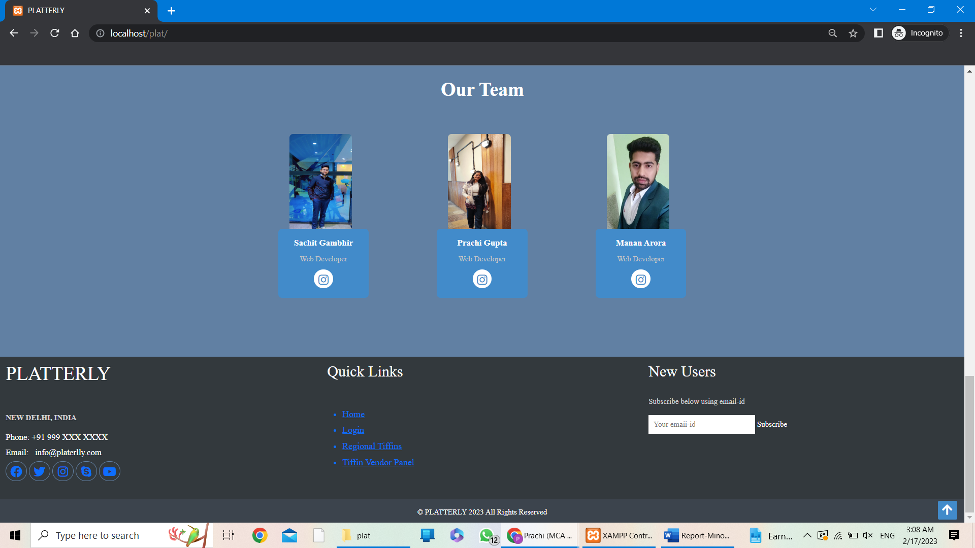

**LOGIN:**

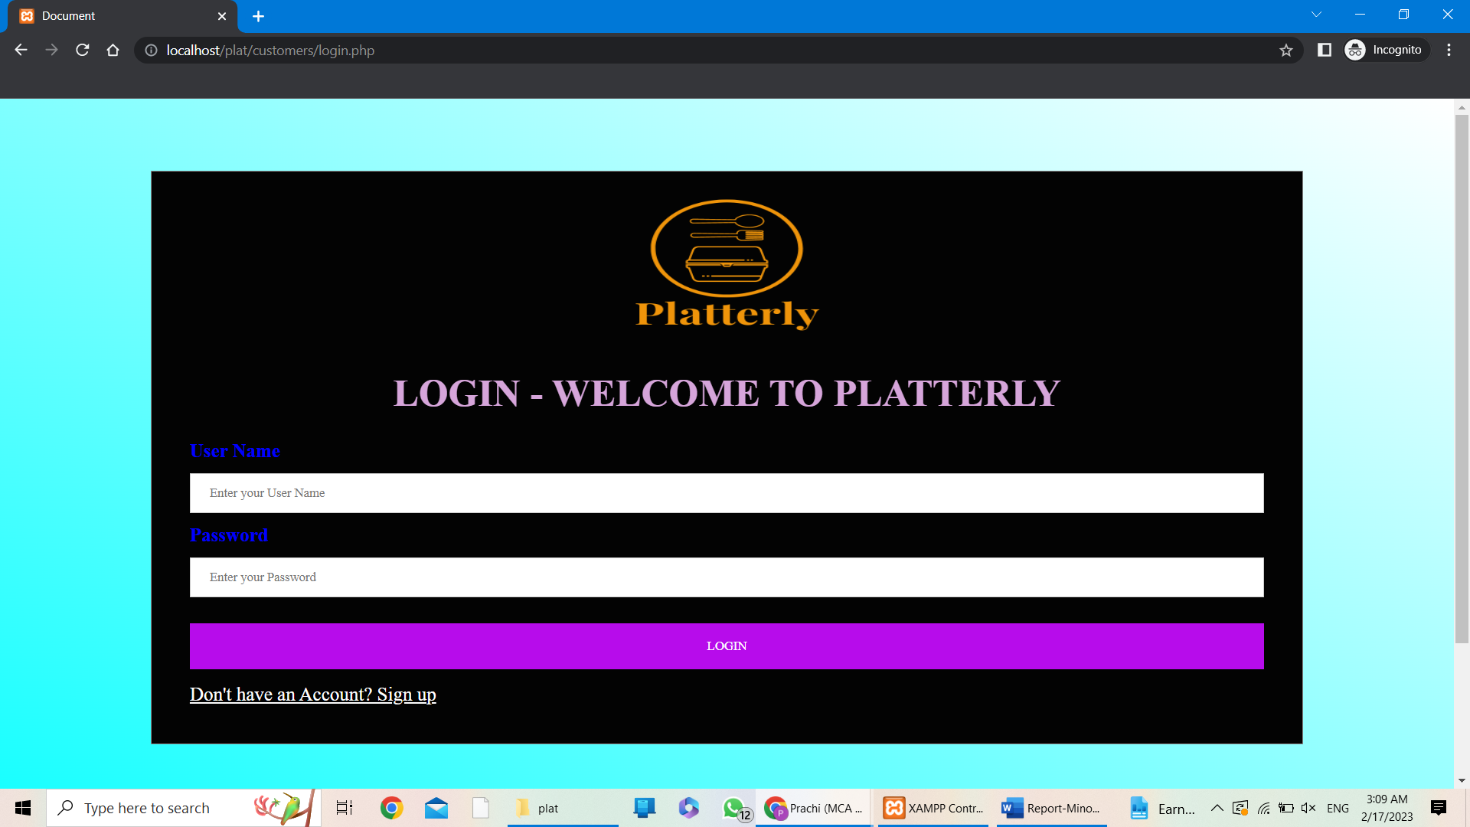

**SIGNUP:**

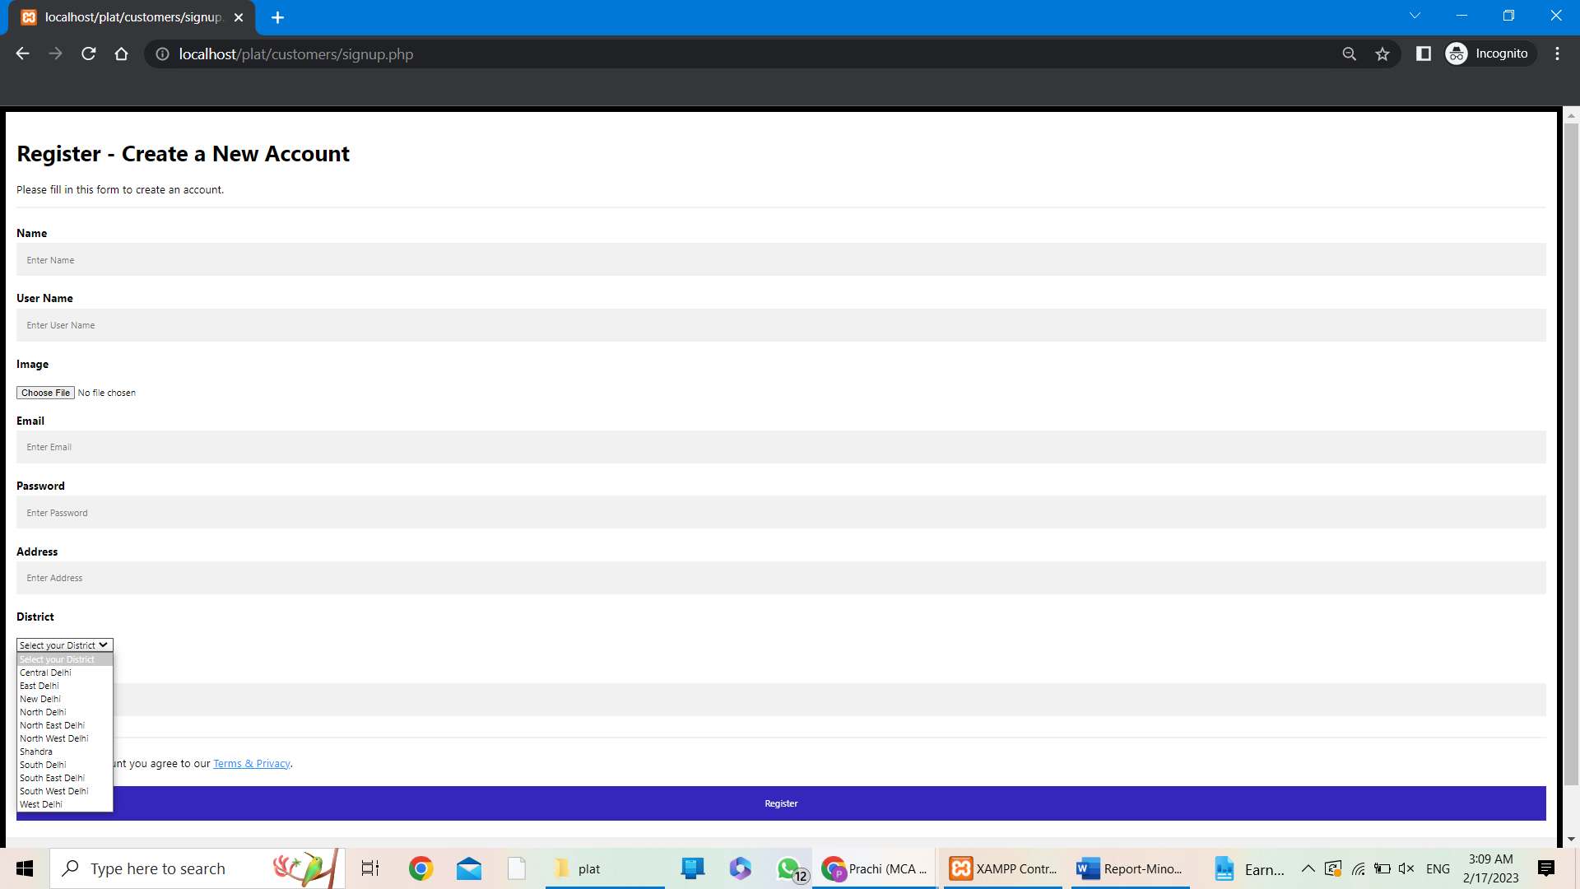

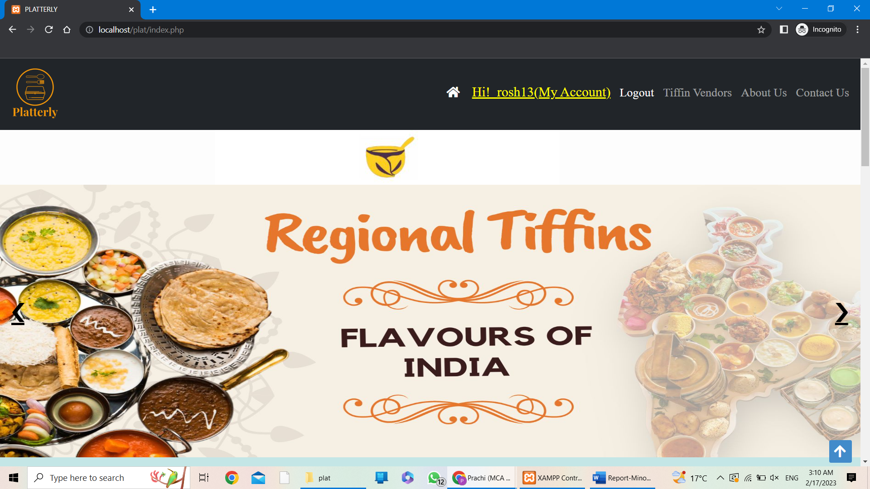

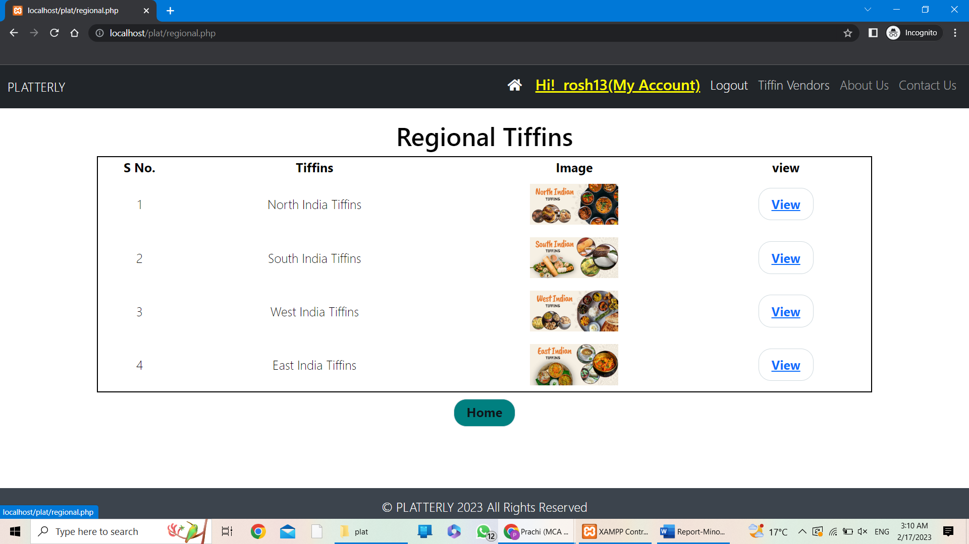

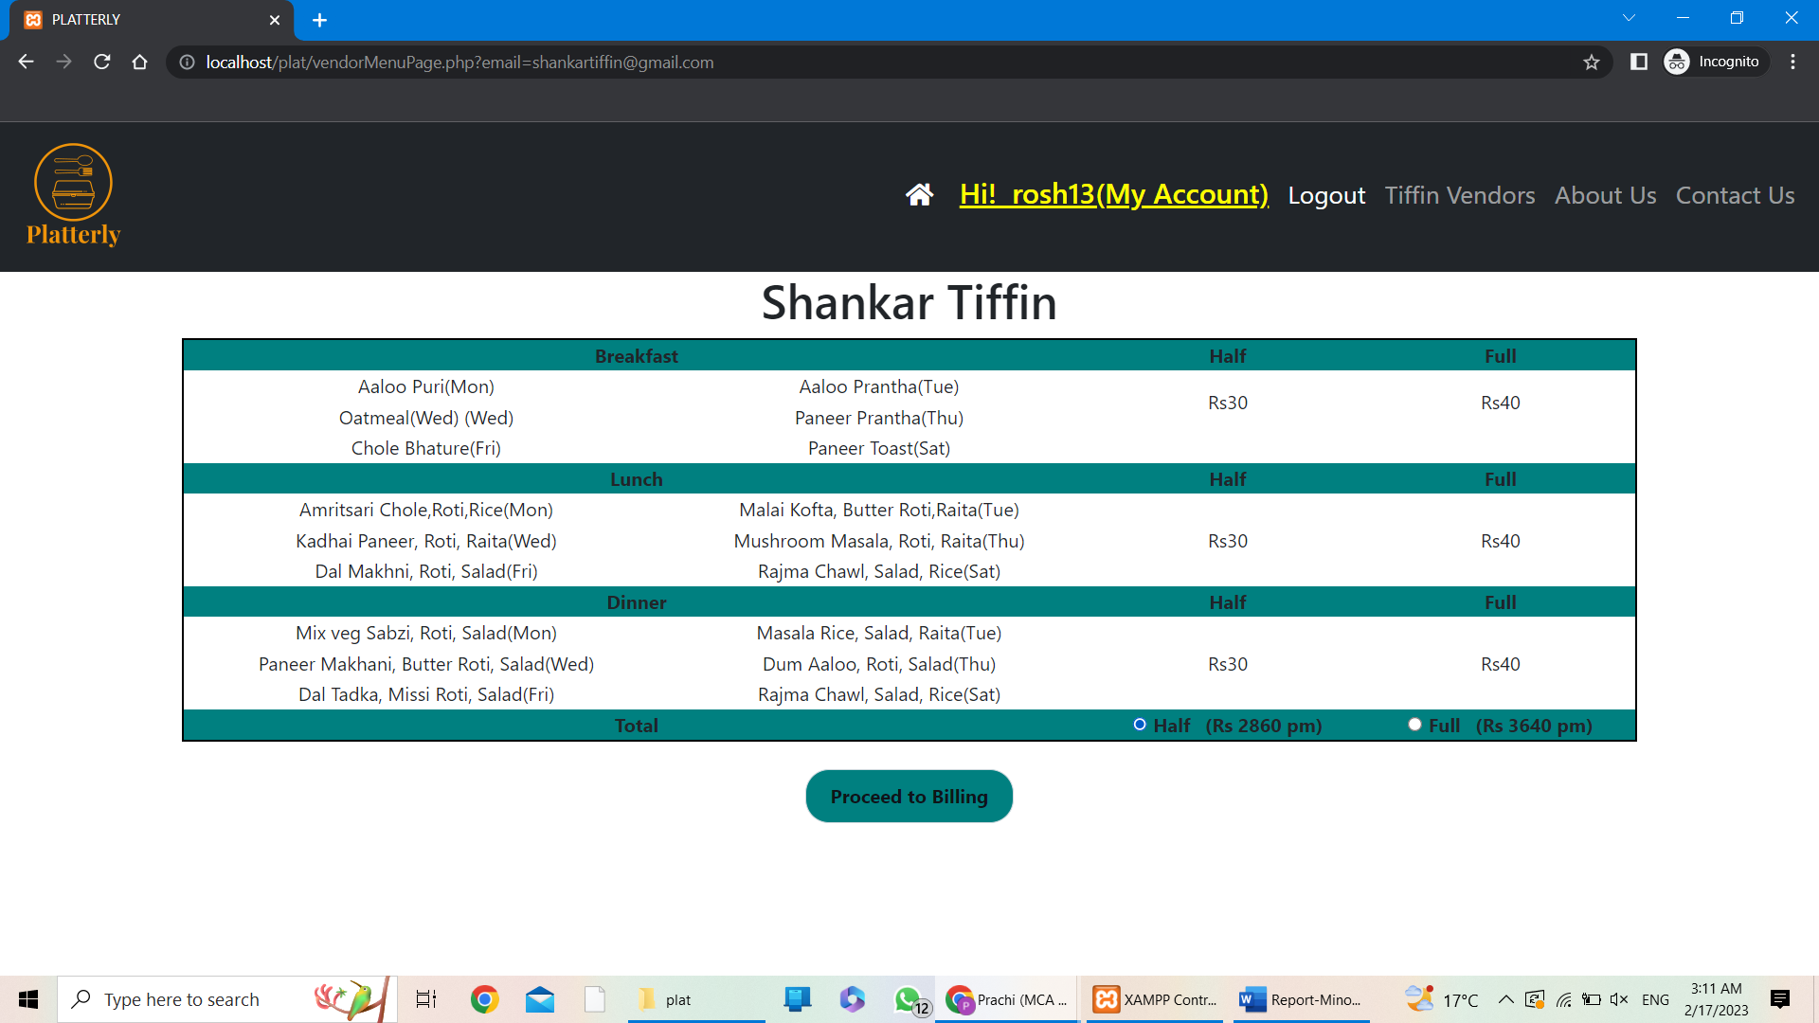

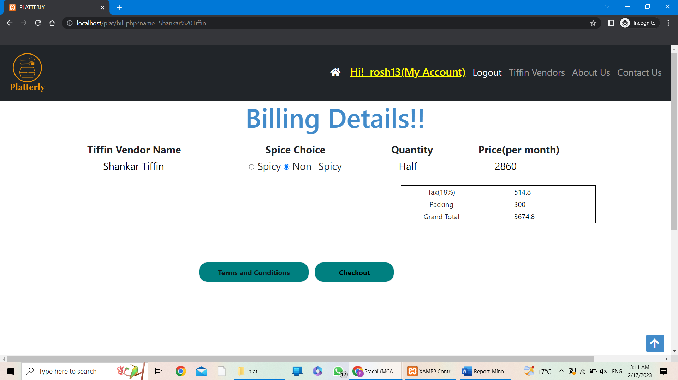

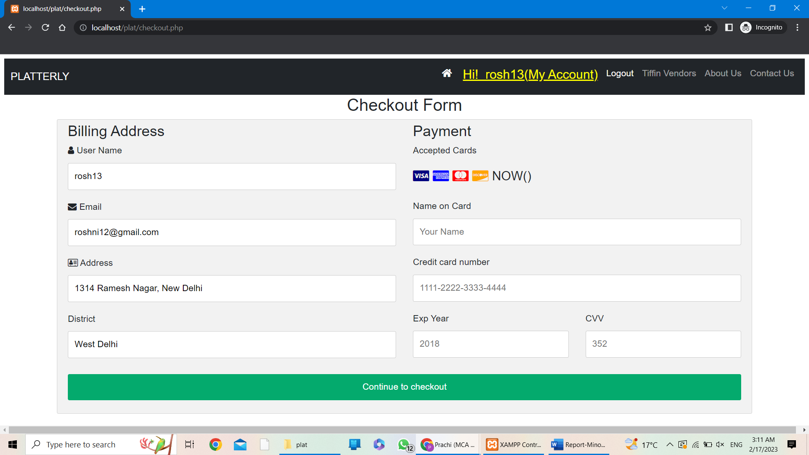

**TIFFIN VENDORS LOGIN:**

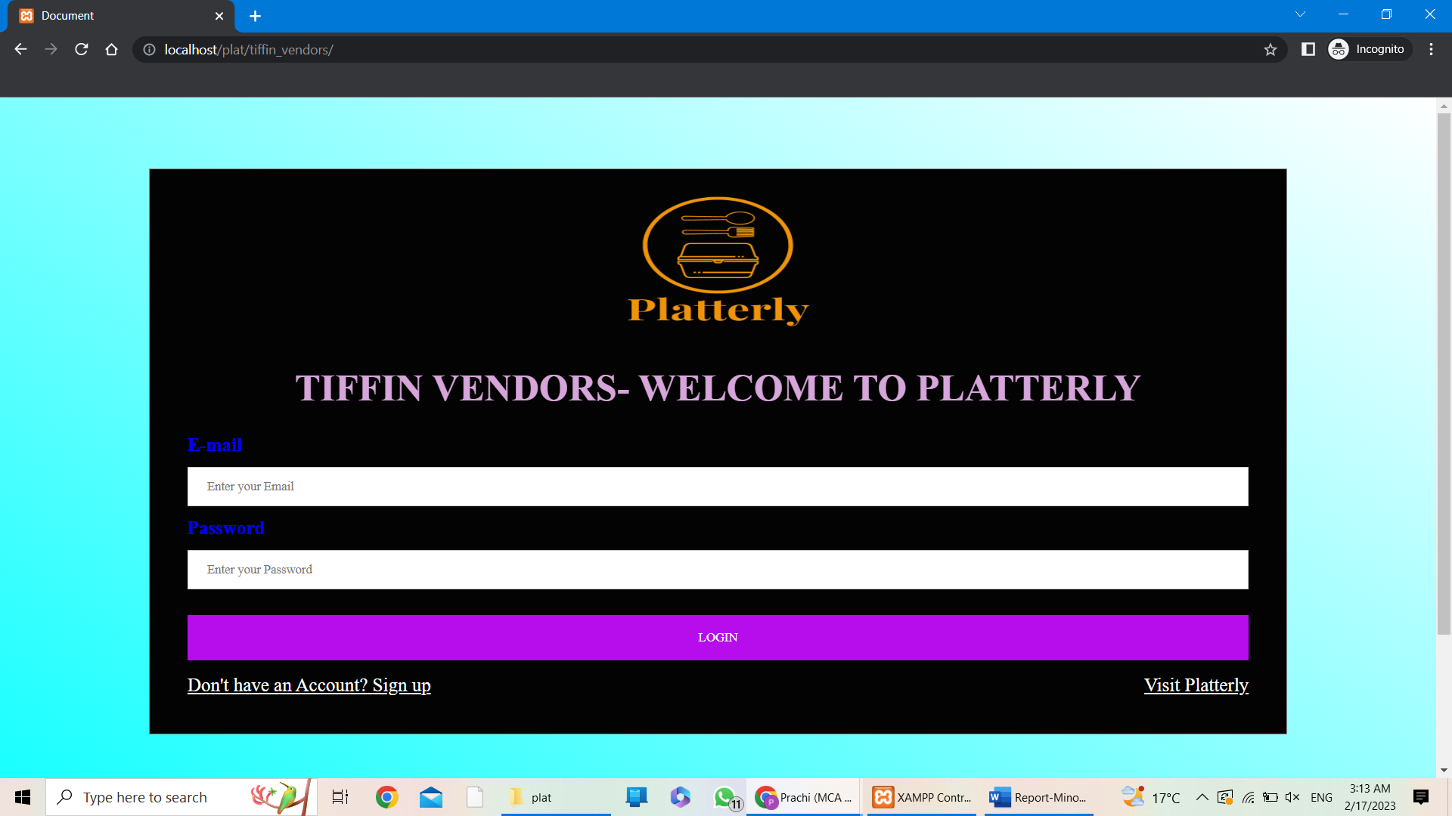

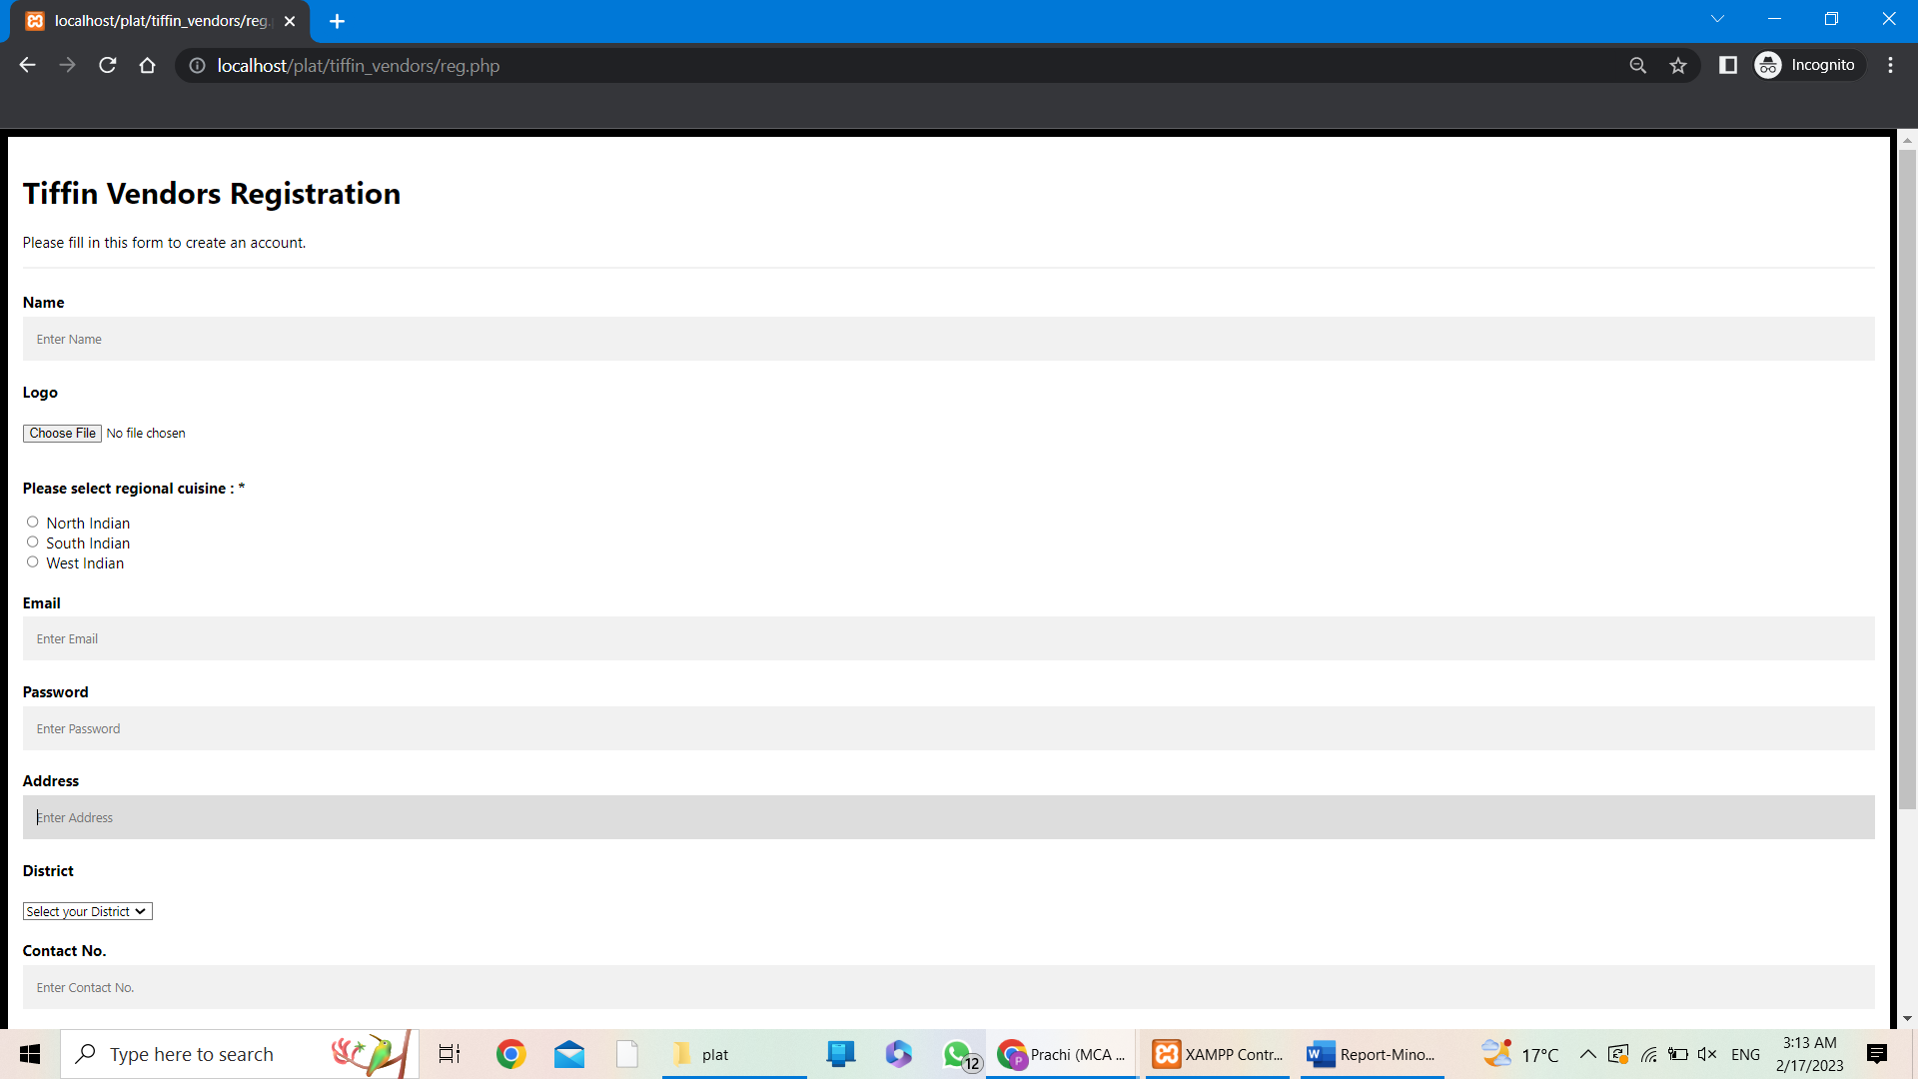

**Adding Menu Items:**

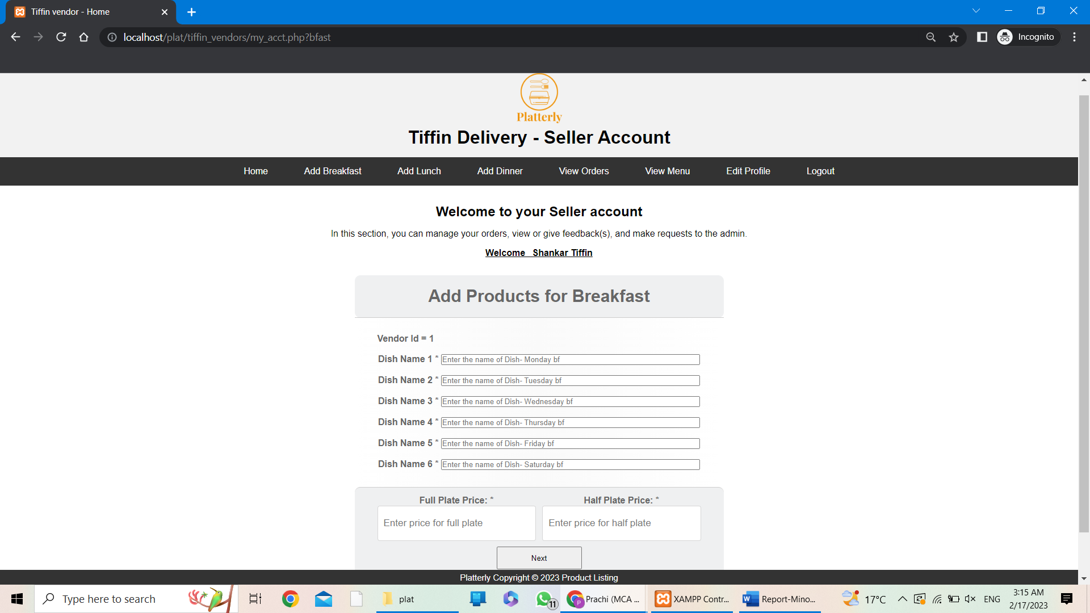

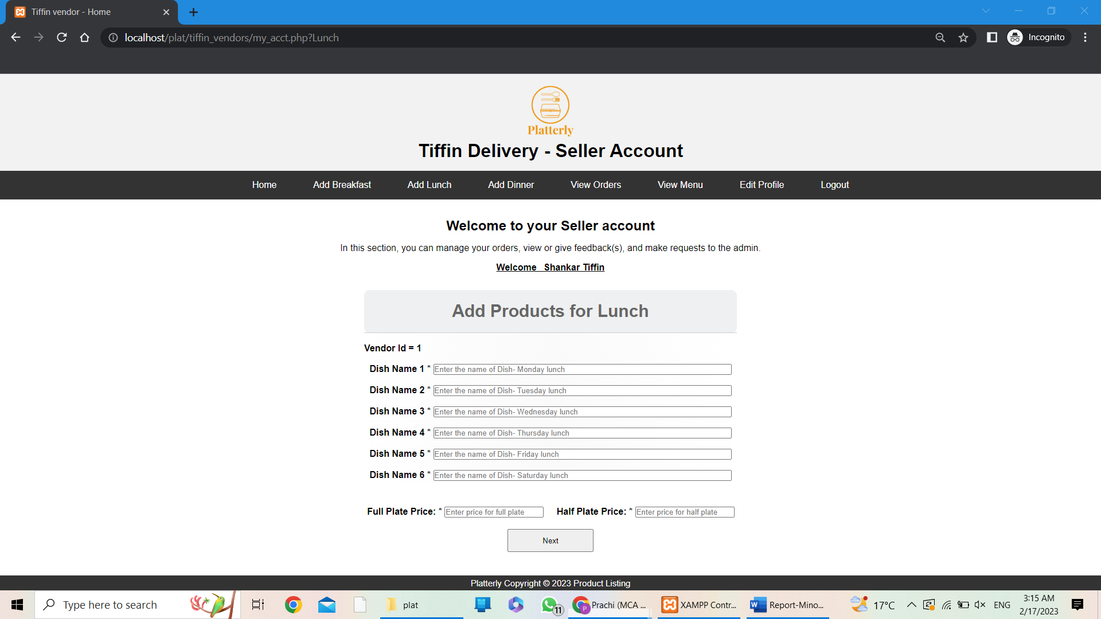

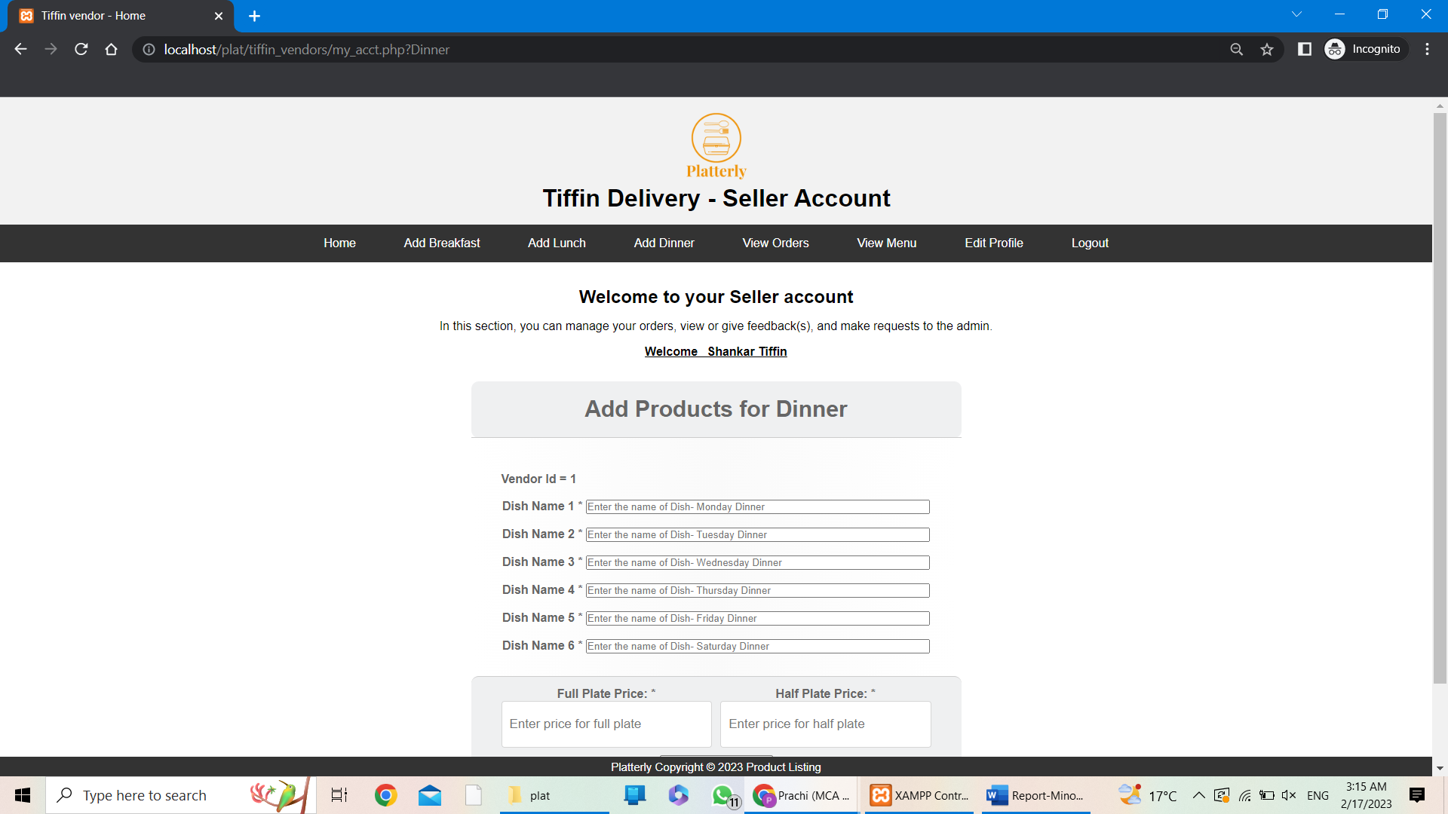

**VIEW ORDERS:**

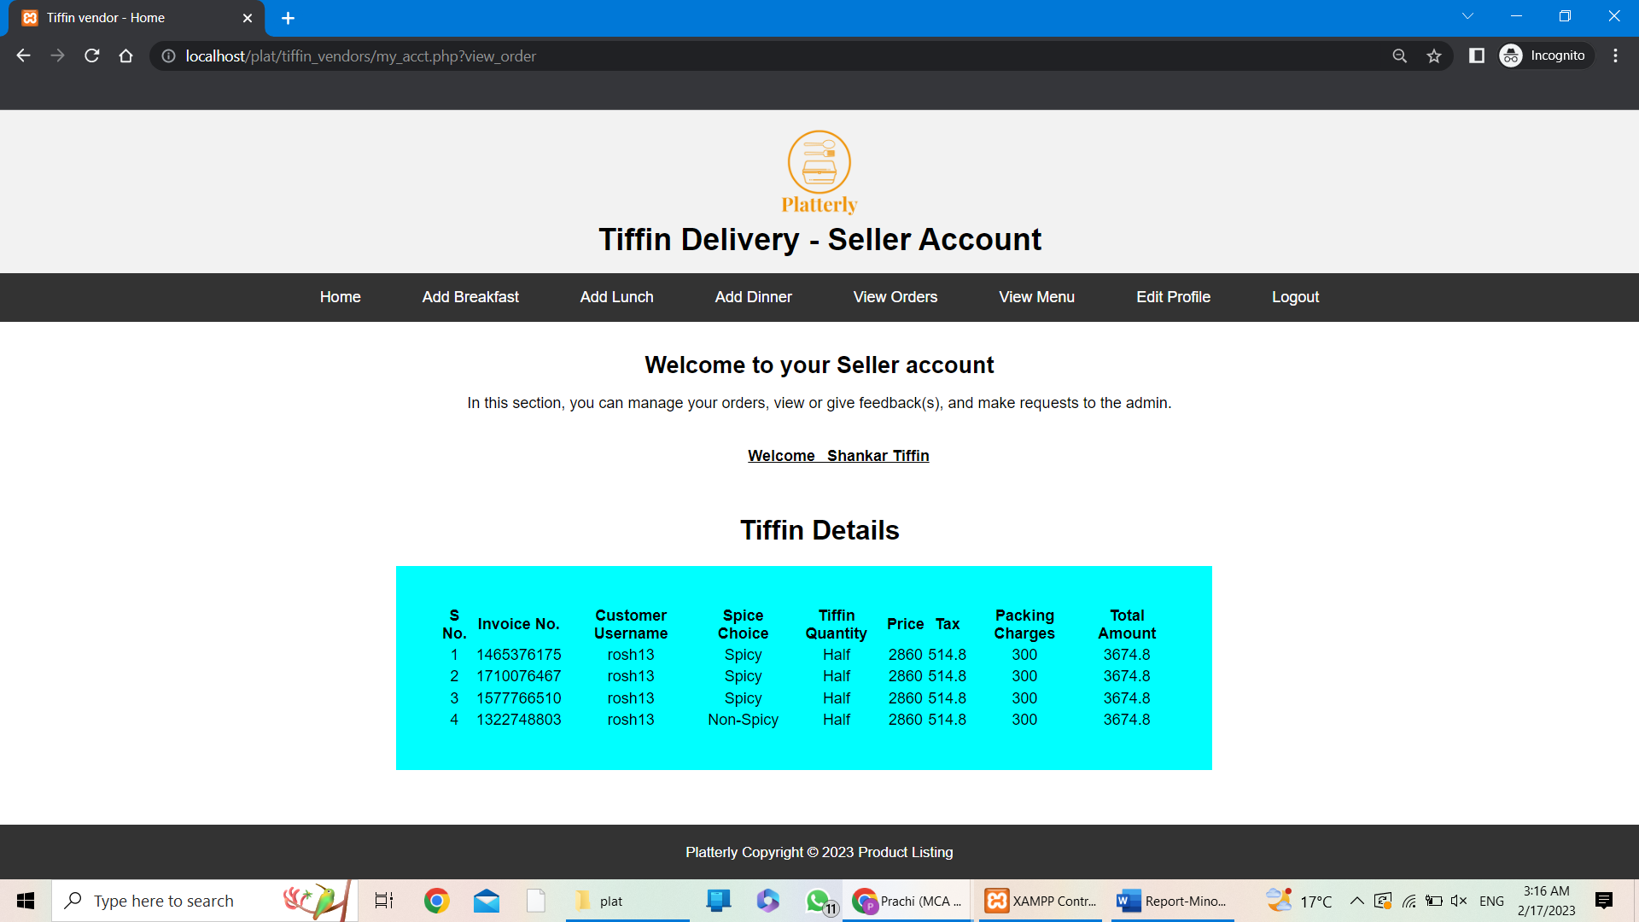

**VIEW MENU**

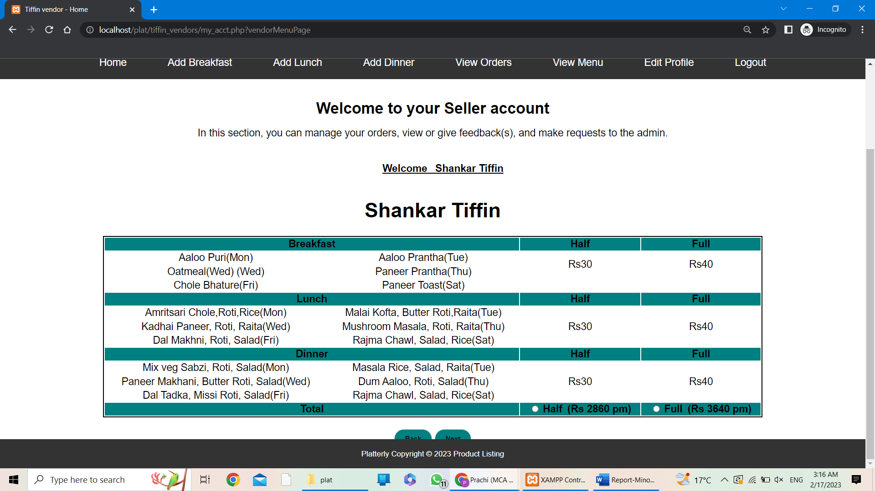

**EDIT ACCOUNT**

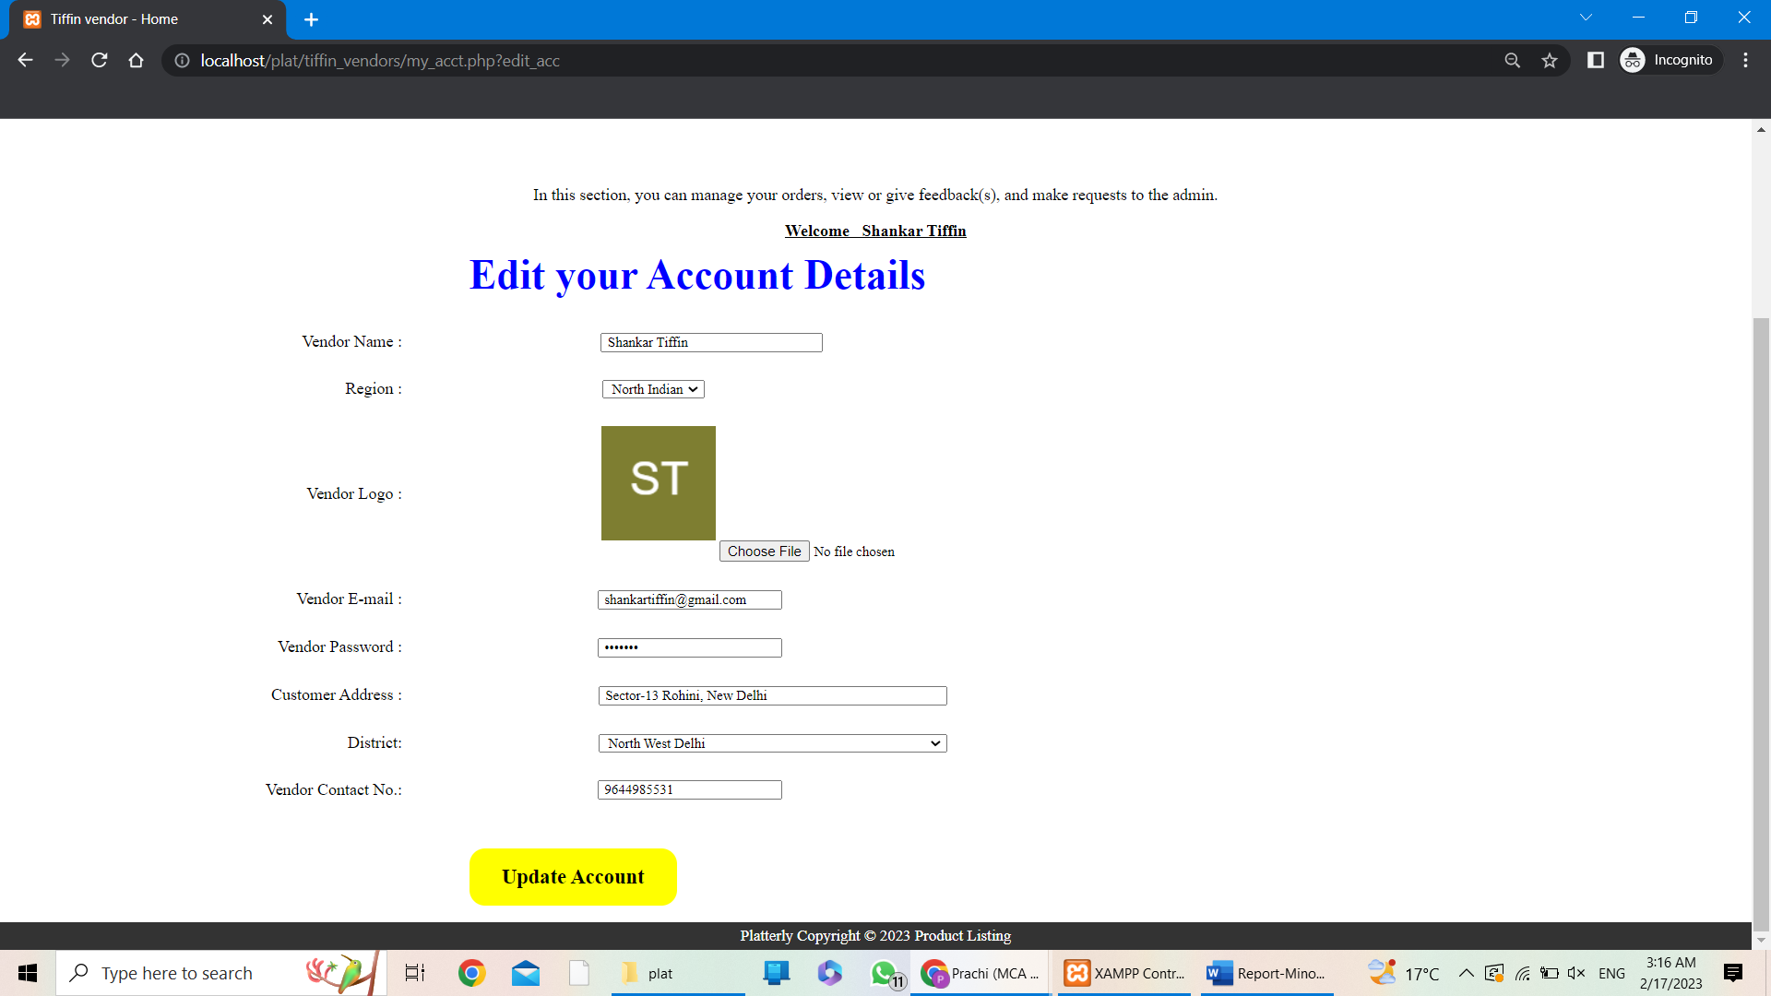

**ADMIN PORTAL LOGIN**

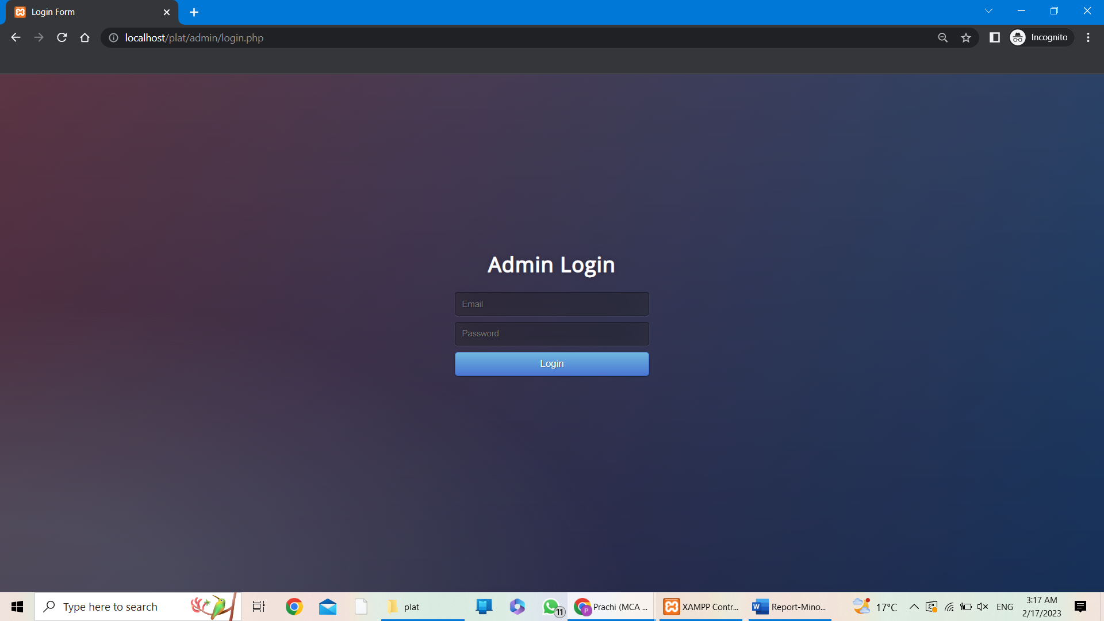

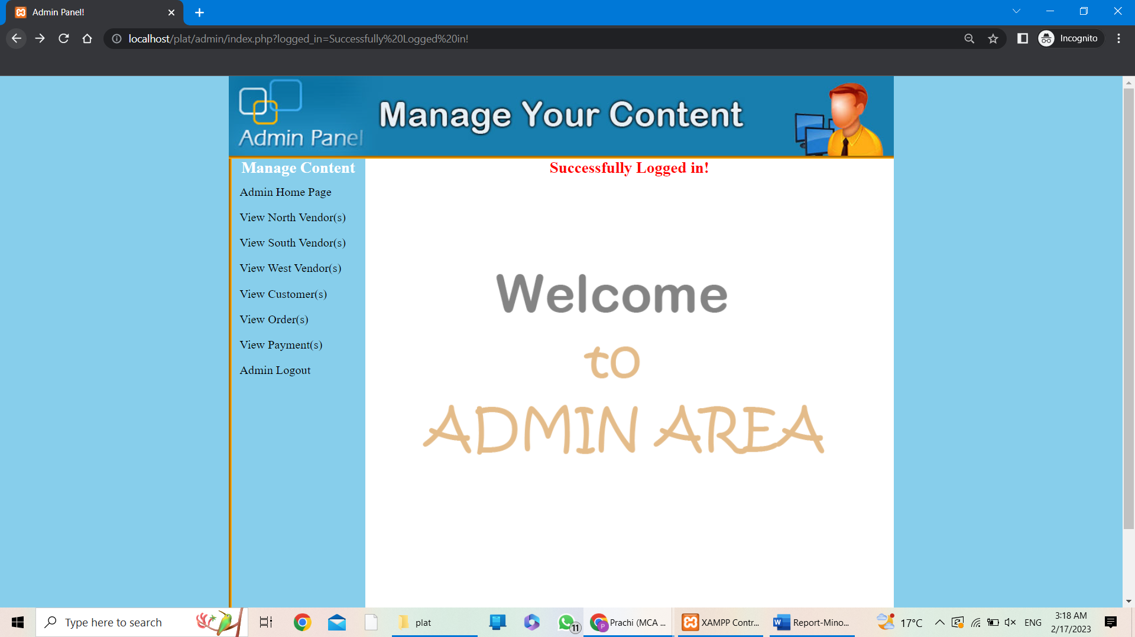

**VIEW / DELETE VENDORS**

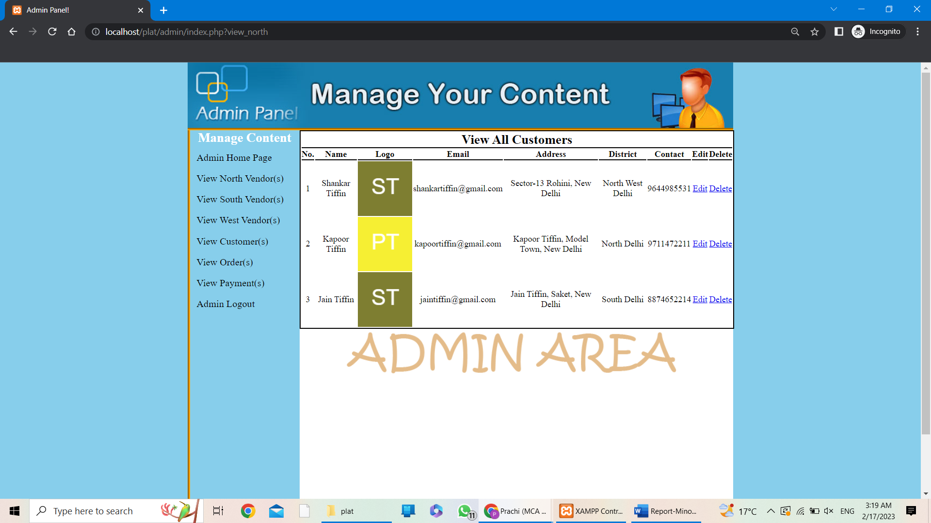

**VIEW / DELETE CUSTOMERS**

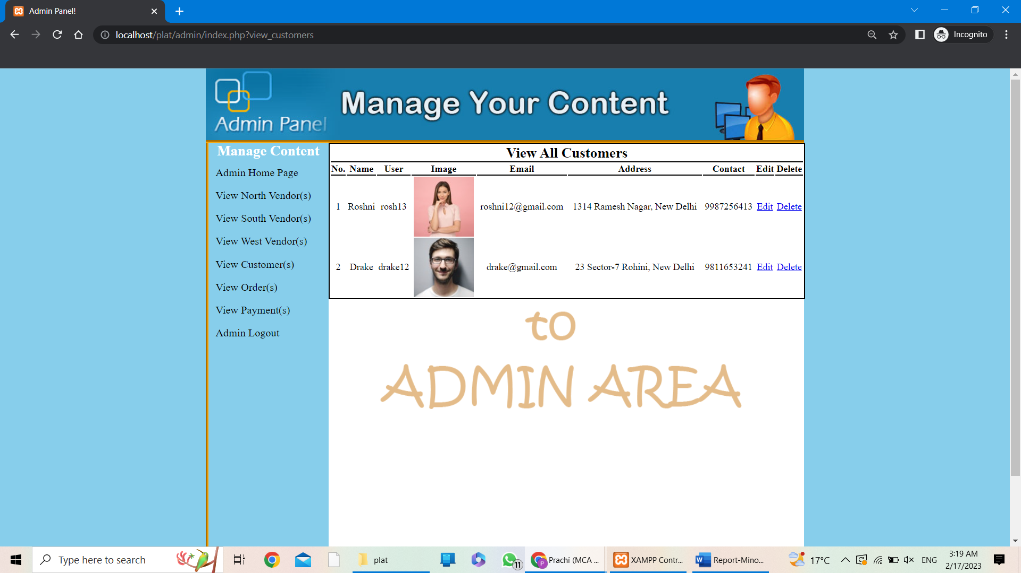

**VIEW ALL ORDERS**

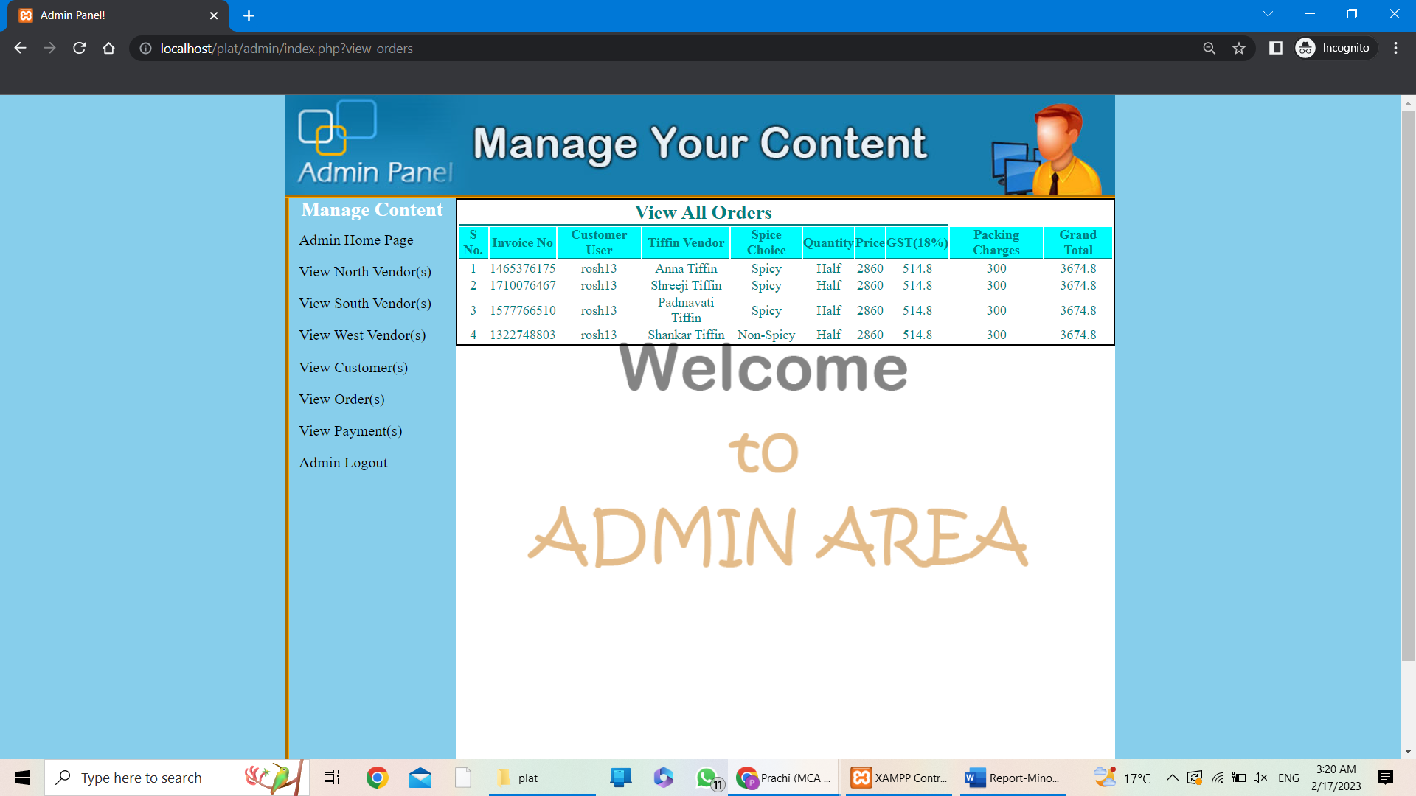

**VIEW ALL PAYMENTS**

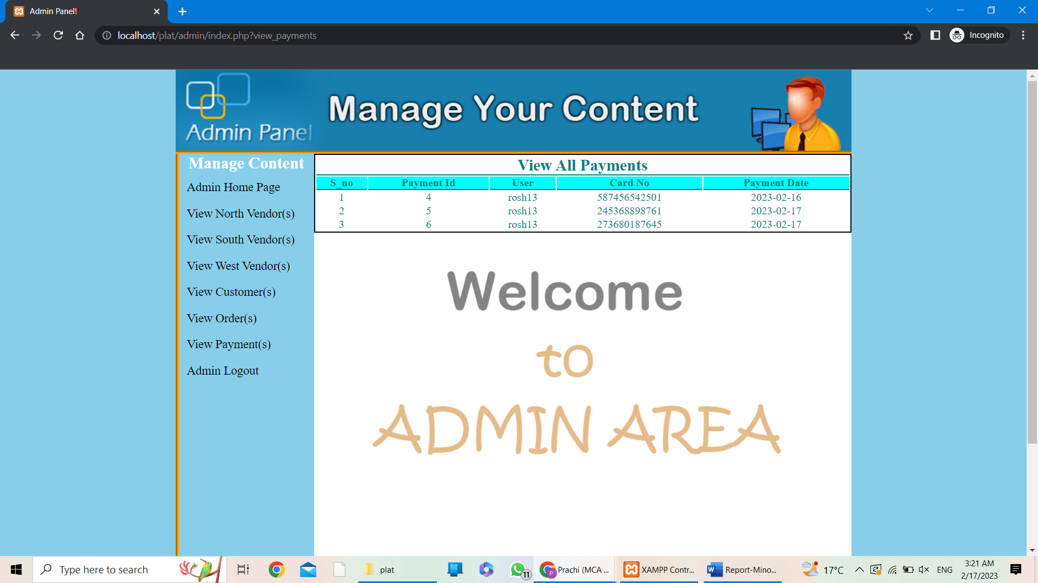

**TABLES IN DB:**

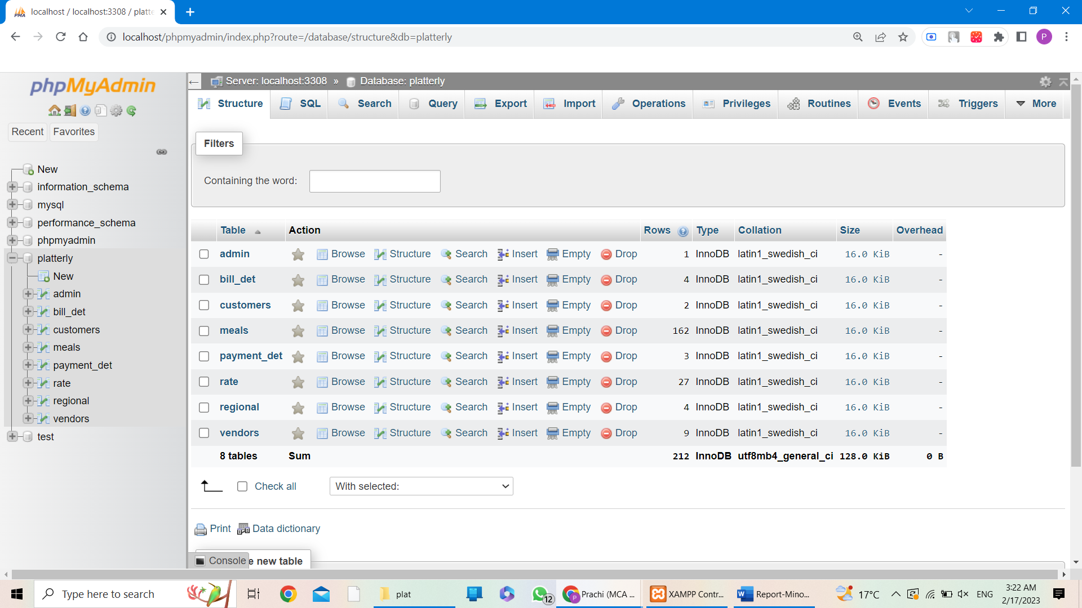**TABLES:**

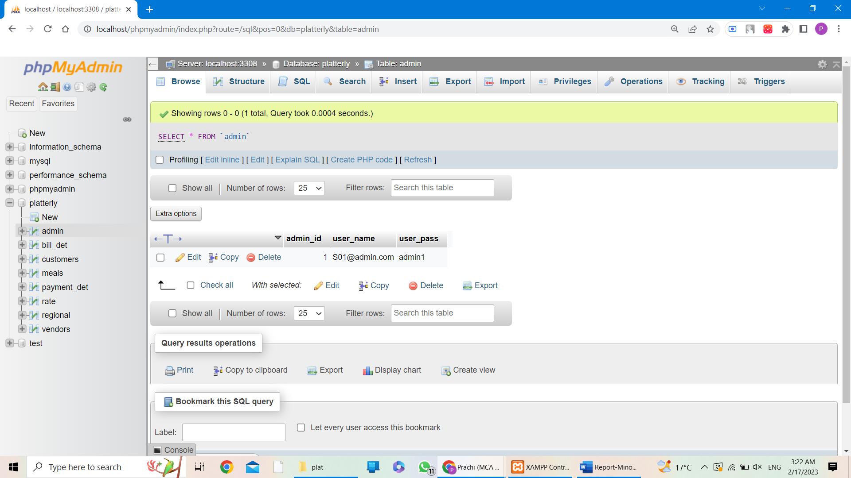

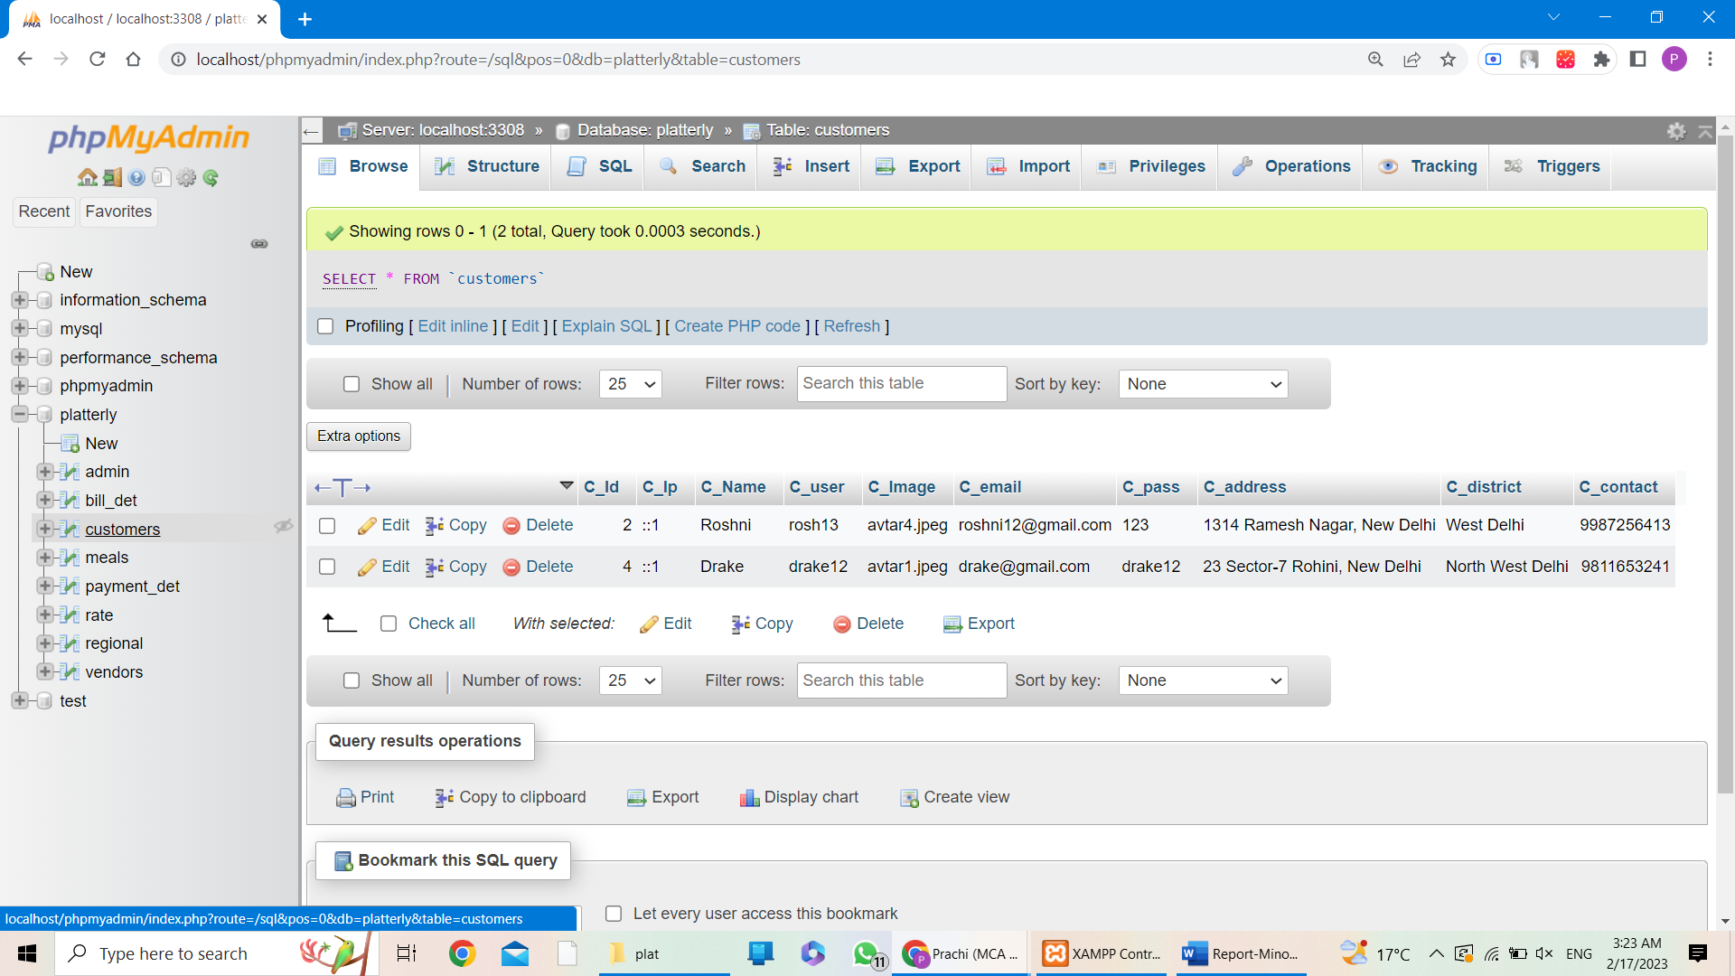

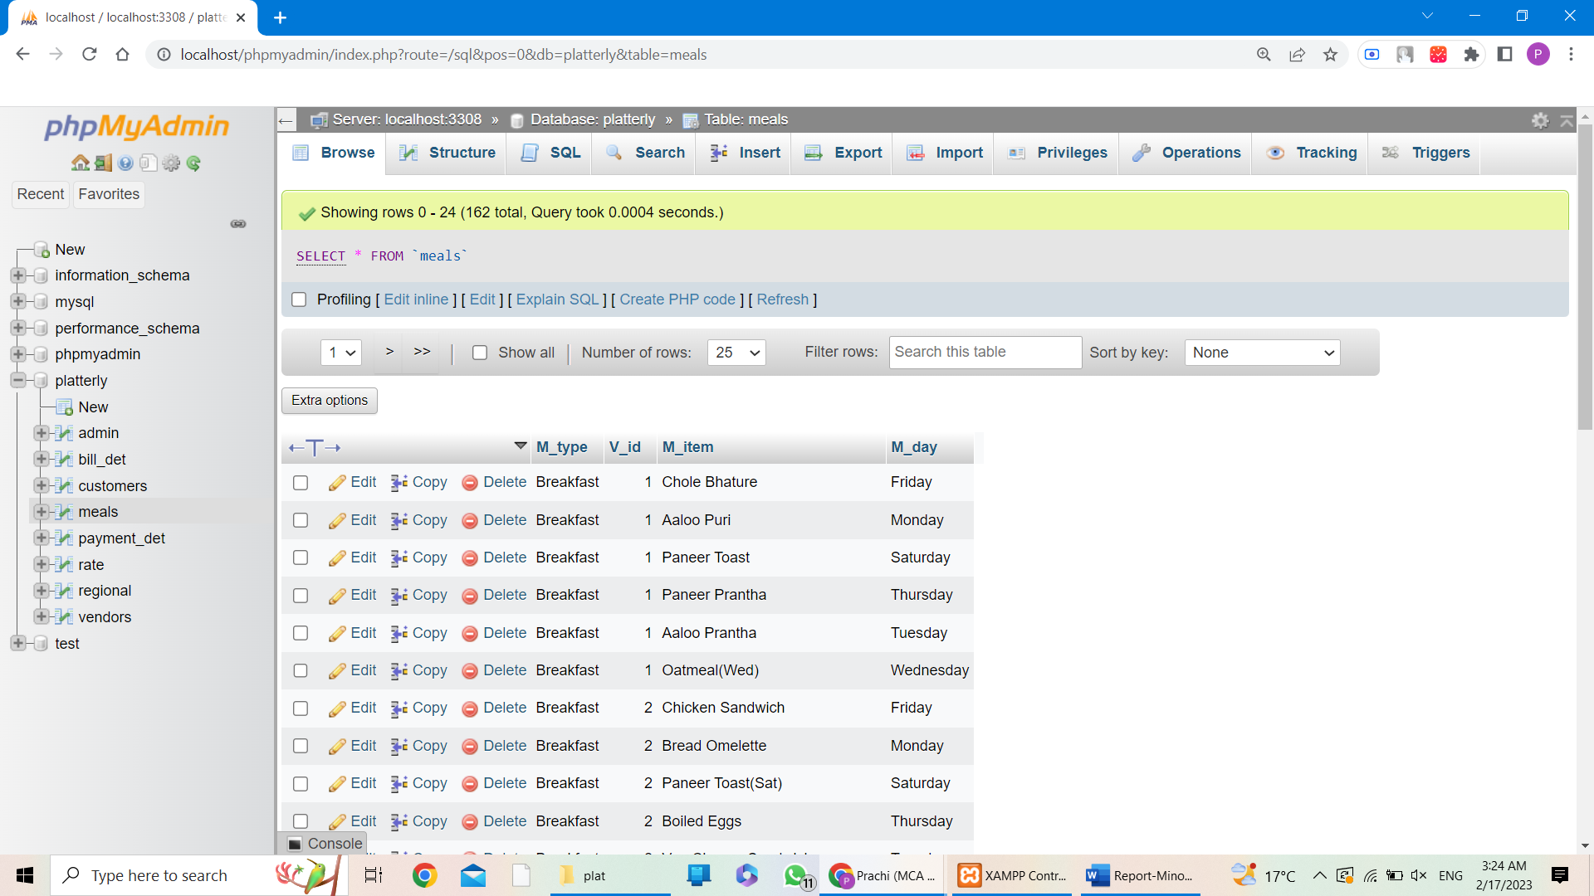

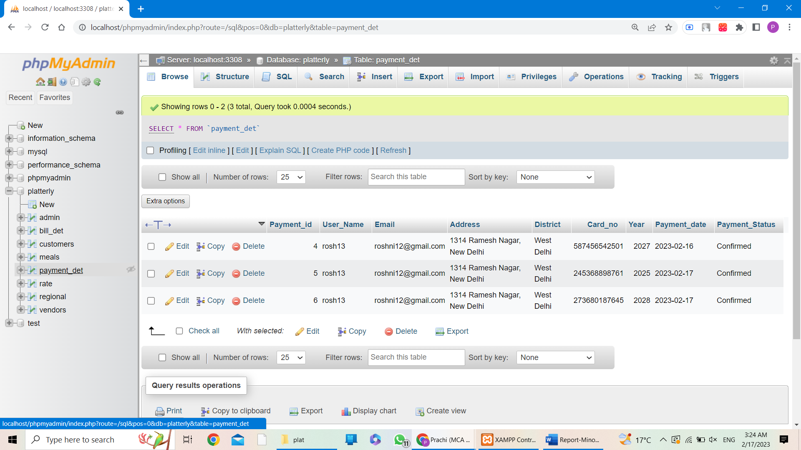

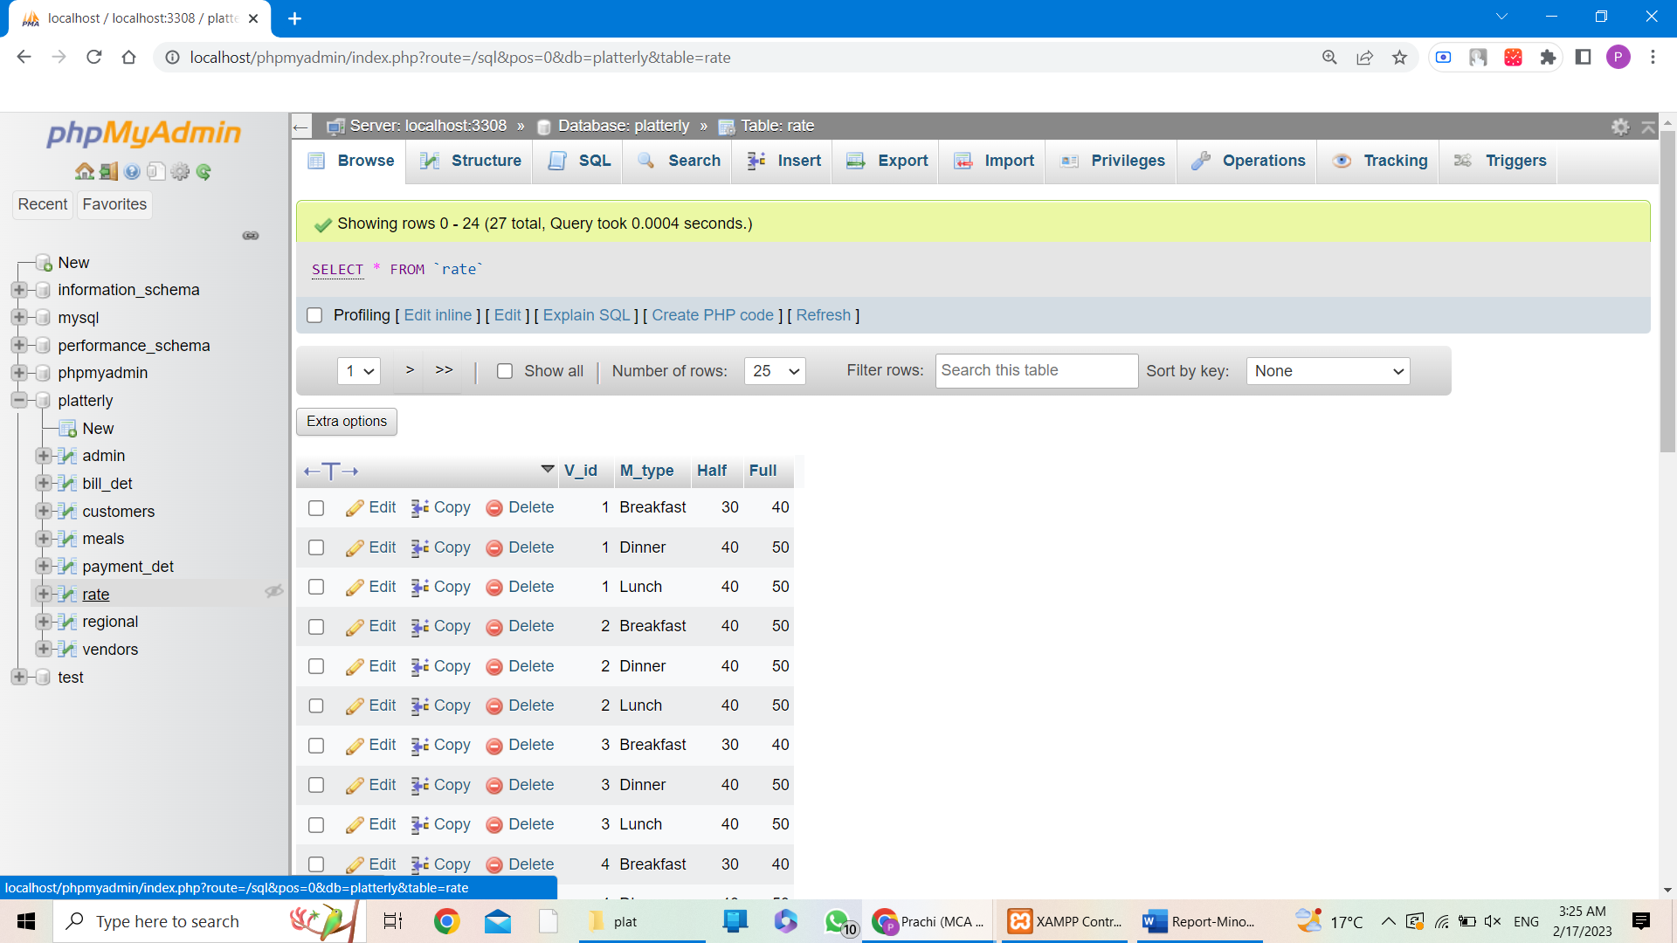

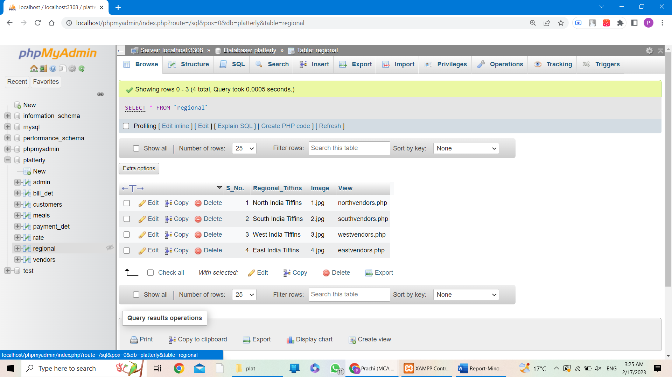



**CHAPTER 4: Conclusion And Future Scope**

**4.1 Conclusion & Future scope**

**Conclusion:** Platterly can provide a convenient and reliable platform for customers to order nutritious and delicious meals. The website can help the business to reach a wider audience and grow its customer base. By providing an easy-to-use interface for ordering, payment, and delivery, the website can enhance the customer experience and improve customer satisfaction.

**Future Scope:** Platterly tiffin service website can explore various avenues for growth and expansion. For example, the website can integrate with social media platforms to reach more customers and improve engagement. The business can also consider adding new features like meal customization, nutritional information, and user reviews to enhance the customer experience.

Another area of potential growth is expanding the geographical coverage of the service. By partnering with local suppliers and delivery services, the business can extend its reach to more areas and offer a wider variety of meal options.

Overall, the Platterly tiffin service website has significant potential to become a successful and innovative platform for healthy and convenient meal delivery. With continued innovation and investment in technology, the website can continue to meet the changing needs and expectations of its customers and stay ahead of the competition.

**4.2 Bibliography**

**For HTML & CSS:**

* https://www.w3schools.com › html › html_css
* https://developer.mozilla.org › en-US › Learn › CSS

**For PHP:**

* <https://www.php.net>
* https://www.javatpoint.com › php-tutorial
* https://www.geeksforgeeks.org › php-tutorials
* <https://www.udemy.com/course/php-for-beginners-/>

**For images references:**

* <https://www.google.co.in/imghp?hl=en&ogbl>
* https://www.shutterstock.com/

THANKYOU!